**Mapping Lightning Strikes across Gujarat State for the Year 2022 and Development of Prediction Model**

Pratyush Rao1, Gautam Shah1, Nimit Savant1,Seema Lakhani1,Alok Taori2*and Pallavi Ghalsasi1*

1School of Engineering and Technology, Navrachana University, Vasna-Bhayli Road, Vadodara- 391 410, Gujarat, India

2 National Remote Sensing Center (NRSC), Indian Space Research Organization (ISRO), Hyderabad

**Introduction**

Lightning as a deadly natural phenomenon is known to mankind for a very long time. In the year 1752, Benjamin Franklin with his famous kite flying experiment, discovered that lightning is connected with electrical charges. Since then, it is understood that Lightning is a sudden, electrostatic discharge creating a giant spark’ or ‘flash’ when charged atmospheric regions temporarily equalize themselves through this discharge. Although lightning happens through all the seasons, it is normally observed during thunderstorms.

For normal atmosphere, air acts as a dielectric between the opposite charges within the cloud, between different clouds and between the cloud and the ground. Upon sufficient buildup of the opposite charges, dielectric breakdown happens and there is a rapid discharge of electricity. The reasons for the charge build up is yet to be known completely but is thought to be a triboelectric effect wherein the heavy graupel particles moving downwards gain negative charge and light ice flakes along with small supercooled water droplets moving upwards gain positive charge during their collisions. Depending on the location of charge build up, lightning can occur as intra-cloud lightning, cloud to cloud lightning or cloud to ground lightning. The polar distribution of charges along with movement of charges are responsible factors for the spread and branches of lightning discharge in space and time resulting in multiple lightning patterns like bead lightning, ribbon lightning and anvil crawlers etc.

As the world is becoming more and more susceptible to rapidly changing climatic conditions, it is also using advanced technology to mitigate the loss of life and damage to property during such incidents and build a robust disaster management system. In India, ‘Lightning’ can be considered as a natural disaster as it accounts to 33% deaths (ref). To monitor lightning occurrences over India, National Remote Sensing Centre(NRSC), ISRO has established a network of long range lightning detection sensors (LDS) with 50% overlap, to give more accuracy. In present article, authors have mapped lightning incidences in the state of Gujarat for the year 2022 and have analyzed their occurrences with respect to various parameters. We have also developed a prediction model that aims to foresee these fatal events and help the Government implement protective policies in the geographical regions vulnerable to being struck by lightning.

**Data collection**

***Lightning Data Collection***

Lightning detection sensor (LDS) installed by National Remote Sensing Center (NRSC), Indian Space Research Organization (ISRO), Hyderabad confirms the geographic location of a lightning strike using time of arrival (TOA) algorithm (ref). In this method, all stations are assumed to be synchronized by time. When lightning occurs, a constant difference in arrival time is noted between two stations defining a hyperbola. Multiple stations provide multiple hyperbola and the intersection of those define the location. When at least 4 sensors detect this discharge, the location is mapped for lightning. LDS can capture lightning strikes within a radius of 300 km with more than 98% accuracy. The wide network of LDS has given the authors access to the data for the entire state of Gujarat through Bhuvan web portal available at https://bhuvan-app1.nrsc.gov.in/lightning/. The data files downloaded from this portal are in the form of shape files.

***Weather Data Collection***

Lightning was correlated with weather dependent factors (variable) like wind, temperature and geographic factors (fixed) like elevation, ground coverage etc. The data pertaining to these factors was carefully selected and obtained from reputable repositories (ref) in raster or GRIB format. Elevation data in raster format was obtained from <https://www.diva-gis.org/gdata> . Ground Coverage Data in raster format was obtained from<https://livingatlas.arcgis.com/landcover/>. The weather data related to wind and temperature in GRIB format was obtained from <https://cds.climate.copernicus.eu/>.

**Methodology**

***Mapping of Lightning Data***

Lightning data thus collected have been mapped on the state map of Gujarat using freely available QGIS software. Gujarat state district shape file was used as a base map and was overlaid by lightning data containing the geographical coordinates. The default option in QGIS was to make sure that each overlaid map was projected and aligned correctly without having to use coordinate reference system (CRS) option in QGIS. The lightning map was overlaid with certain percentage of transparency so that the base map of districts could show through as a reference map. For better visualization of the data from GRIB file, display properties of the layer were changed for colors in the map, data range etc.

## 

***Data Handling***

In Gujarat, cloud to ground lightning strikes have been rare phenomena. The dataset engineered to use for this prediction model, consists of date, co-ordinates of a region, minimum and maximum temperature on a given date, minimum and maximum apparent temperature on the said date, wind speed, total rain received, total number of hours it precipitated for, shortwave radiation and count of lightning strikes.

Most of the records in the dataset have 0 lightning strikes. Developing a regression model that can give the exact number of lightning strikes per day will be difficult for such a dataset because of that very reason. The approach of prediction used in this dataset is known as a classification model. Instead of predicting the exact number of lightning strikes we have tried to predict the intensity of lightning strikes that the region will be receiving.

To achieve this, we divide our lightning strike count column into three bins. We assign each bin a number for the classification model to interpret. In the model, 0 translates to 0 expected lightning strikes, 1 translates to more than one lightning strikes. It should be noted that this was the methodology that worked the most effectively.

In order to test our predictions, the dataset was divided into two halves, training and testing set. The data in the training set was trained and then the same model was used for predicting the values on the testing set for comparison of the predictions to the actual values. The evaluation of our model is based on these predictions.

The number of lightning strikes in the dataset are mostly zero, in order to develop a model to be more sensitive towards detecting the outliers majority of records that have zero lightning strikes were deleted known as Under sampling.

**Results and Discussions**

***Mapping of lightning incidents with land coverage and simulated weather data***

To comment on whether the said factors do affect lightning incidents or not and their significant effects on the frequency and distribution of the strikes, the GRIB/Raster files for each factor (Elevation (Figure 1a), land coverage (Figure 1b), wind speed and direction (Figure 3) and temperature (Figure 4), were compared to the monthly aggregated level incidents and on maximum day respectively.

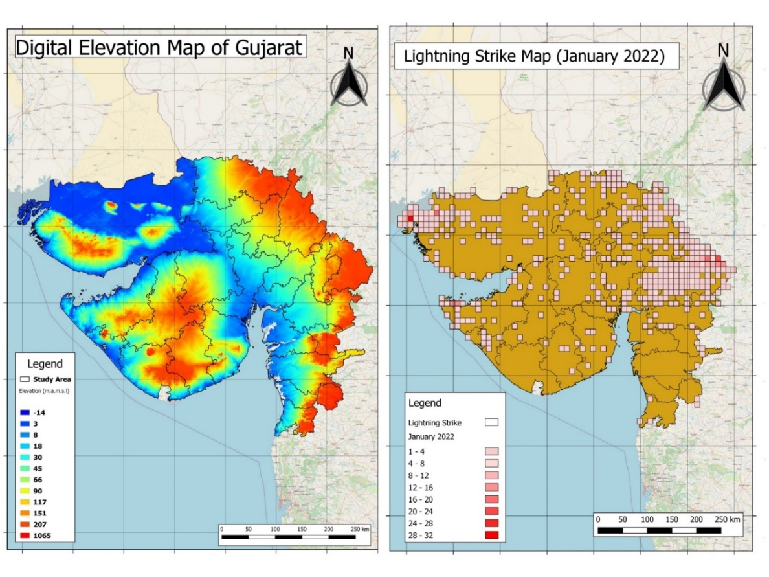 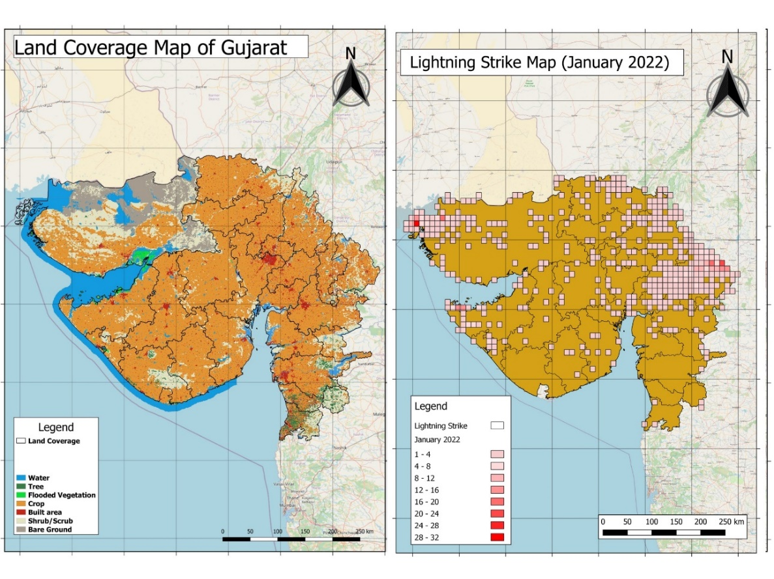

**Figure 1: Elevation map and land cover map for Gujarat State**

From the data (Figure 2), it is observed that February, May, November and December received almost no lightning strikes whereas during June, July and August almost all regions in the state received lightning strikes. The month of September received maximum lightning strikes likely due to convective activity which is the mother cause of lightning and rainfall. The most vulnerable locations shifted from north east to south west from January to April 2022. For the months of May and June, these vulnerable locations shifted from south west to south east and north east. For the months July and August, the vulnerable locations remained in south east locations and shifted from north east to north west. Finally, during September to December, the vulnerable locations remained in south east.

It is normally expected that geographic locations with high elevation can receive more lightning strikes as these regions can provide shortest path for the equalizing charges to complete the circuit. It is found that except for the months of July-September, medium to highest elevation regions (30-1065 meters above mean sea level) receive maximum lightning strikes. During these monsoon months maximum lightning strikes happen in medium to lowest elevation (less than 30 meters above mean sea level). This may be due to the reason that during monsoon the multilayer clouds are more frequent and the vertical extent is larger, which may overcome the minimum path of lightning occurrences owing to the elevation effect. Thus, inference on elevation may be difficult as the effect of elevation on lightning is season dependent and it holds a very good relation in pre-monsoon seasons.

There happens to be another incident where significant effect of elevation was seen, on 31st August 2023 (the day maximum lightning strikes occurred in August) winds were flowing from west direction to east. These winds could not flow past the highly elevated regions in south of Gujarat and hence the regions right before that experienced an insane number of occurrences. Same thing happened in Dwarka region of Gujarat in the month of August, it was the only time this region had an enormous count of strokes which is possibly due to the very high elevation of the region right past Dwarka. Many such cases from September to December were observed where there are very high number of strikes right before the regions with very high elevation of land. Hence, said it may be inferred that high elevation affects the frequency and distribution of lightning incidents.

The land coverage map of Gujarat has various types of regions like water bodies, built area and forest regions. Interestingly in monsoon season especially in August, regions with proximity to water bodies and forest received more strikes than the urban spread. Water bodies make an easy target because of the salt concentration which provides them conducting properties and the trees in forests provides much needed elevation and pointed objects. However, the focus has also been the built area from September till November. One explainable reason as to why built area has so many incidents is as mentioned in literature (ref) that the frequency of the lightning strikes is directly proportional to the urbanization caused by the enhanced pollution. This, together with high-rise establishments which intend to use more conducting materials such as iron and steel, makes the condition favorable for lightning occurrences. A study by Lal and Pawar (ref) explained that industrialization increases aerosol concentration in a city which in turn acts as a catalyst in cloud formation and affects cloud’s inner workings. Another study by Rosenfield et al. (2008) confirmed that aerosol increases the convection in cloud up to 50% and peak updraft up to 20% which confirms that lightning will increase with increase in aerosols. These aerosols are a part of the bigger problem Air pollution, which are responsible for stronger and worse thunderstorms. Another possible reason for the focus on built land could be the population density. More the population, more the heat, more pollutants, and warmer atmosphere that has higher moisture which is one of the factors for lightning to occur. This may be the plausible reason that high concentration of lightning strikes in built area with tall buildings is observed.

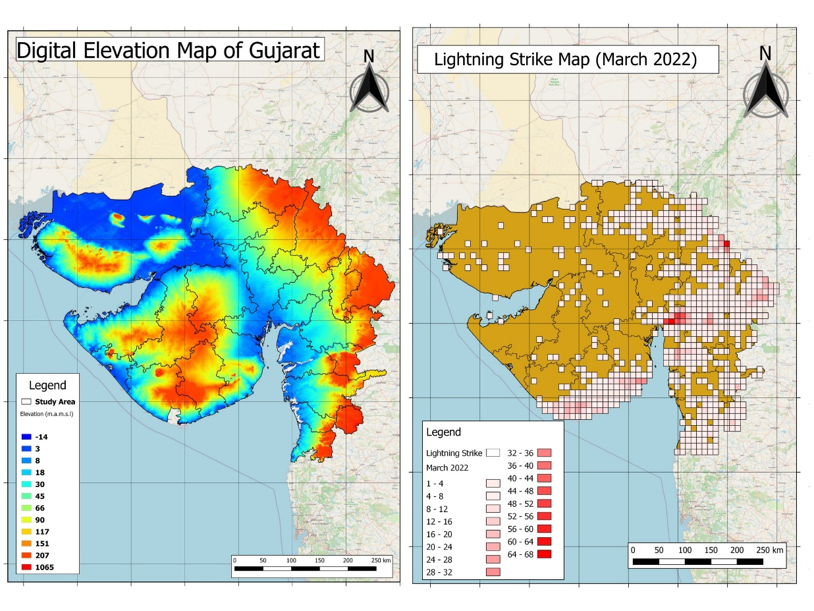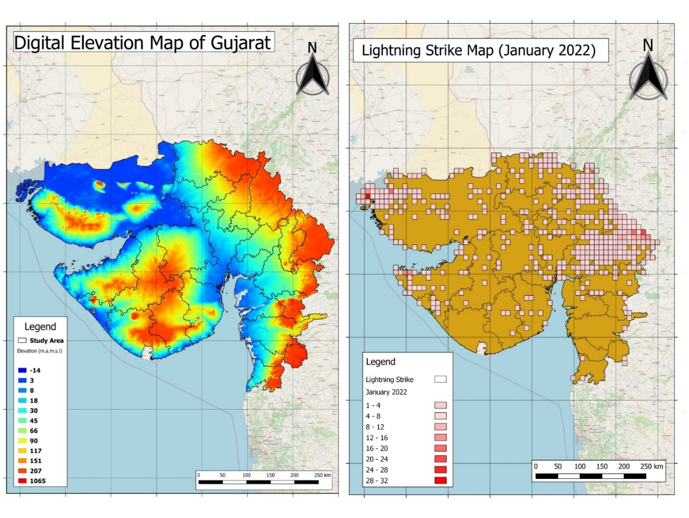

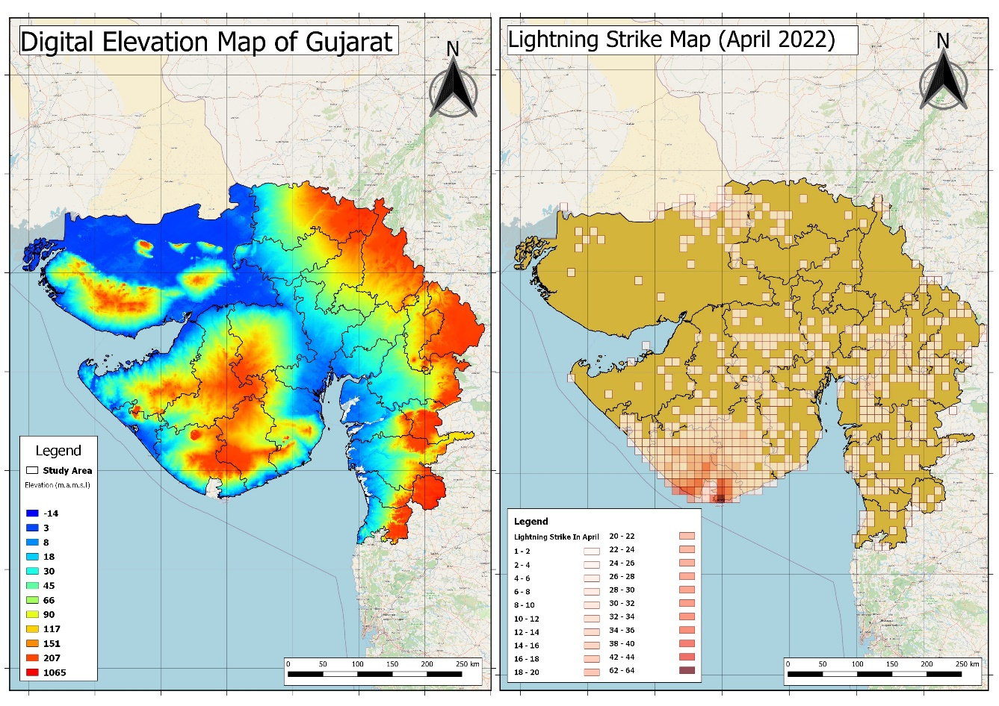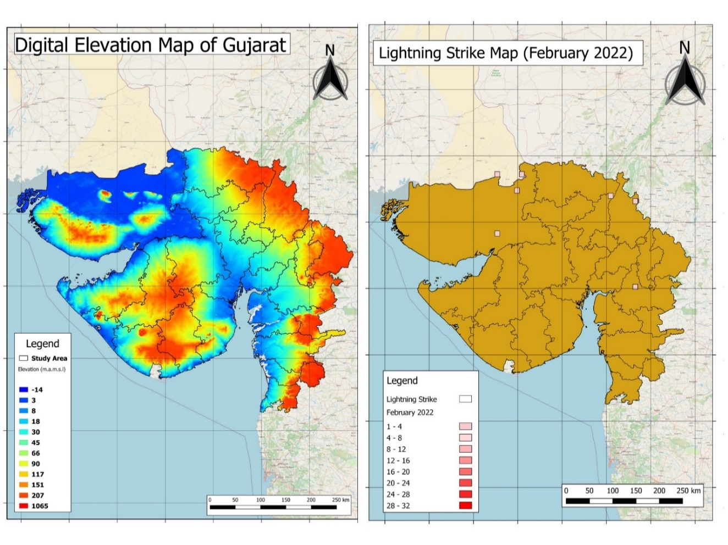

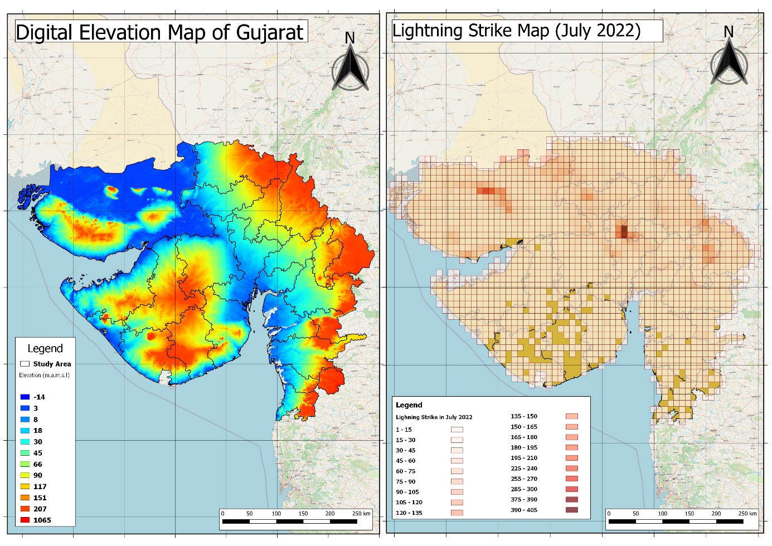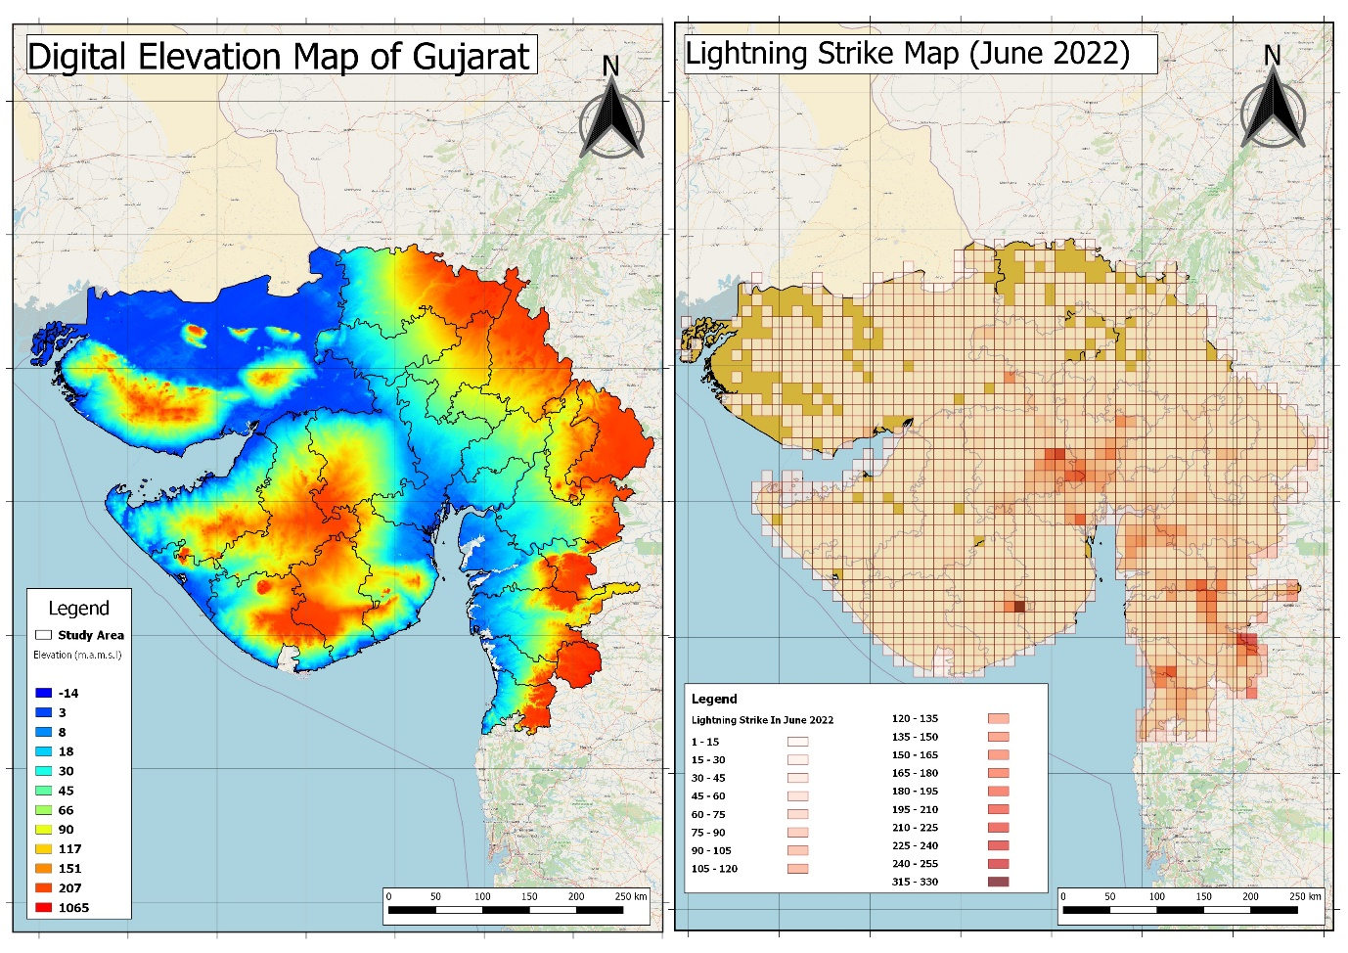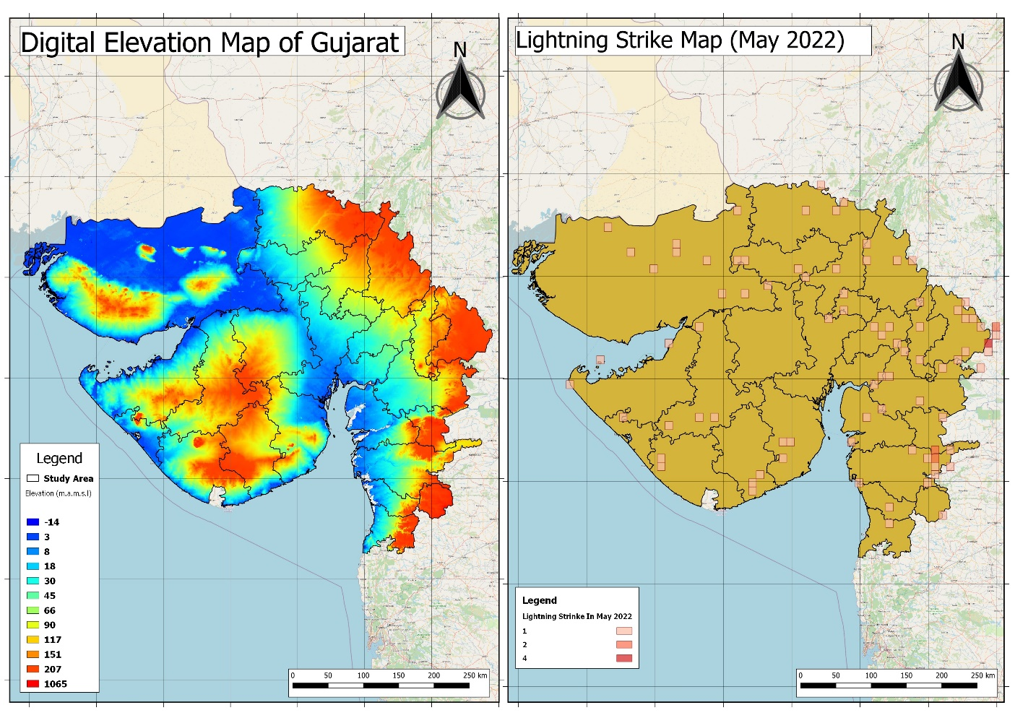

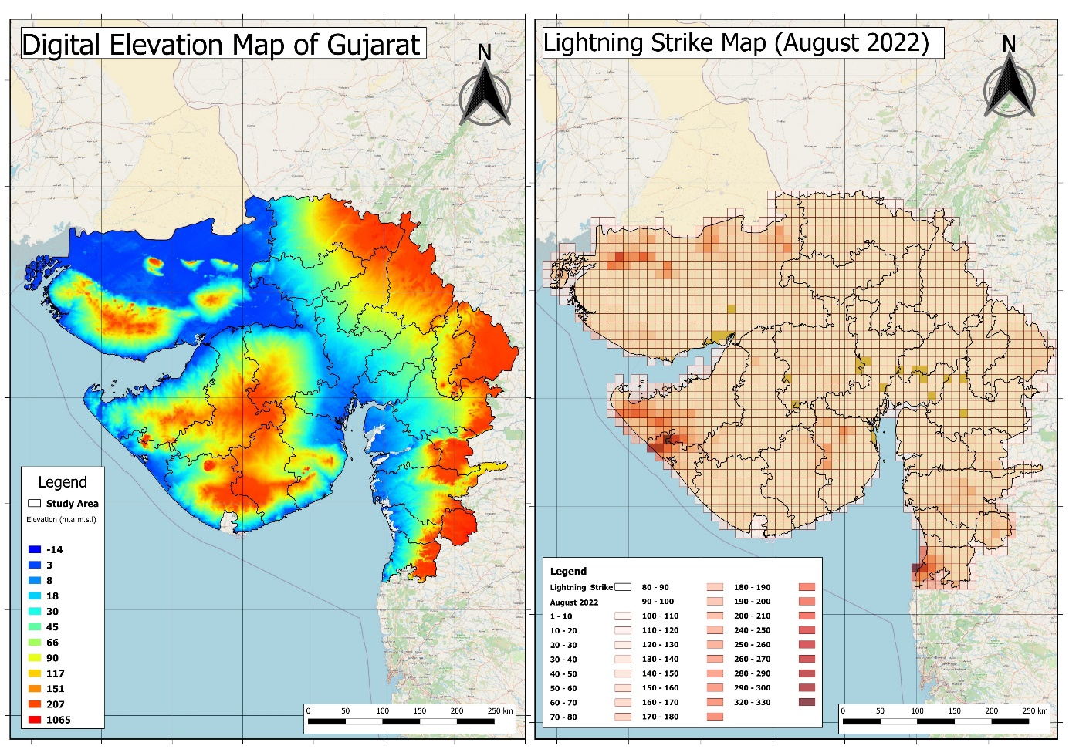

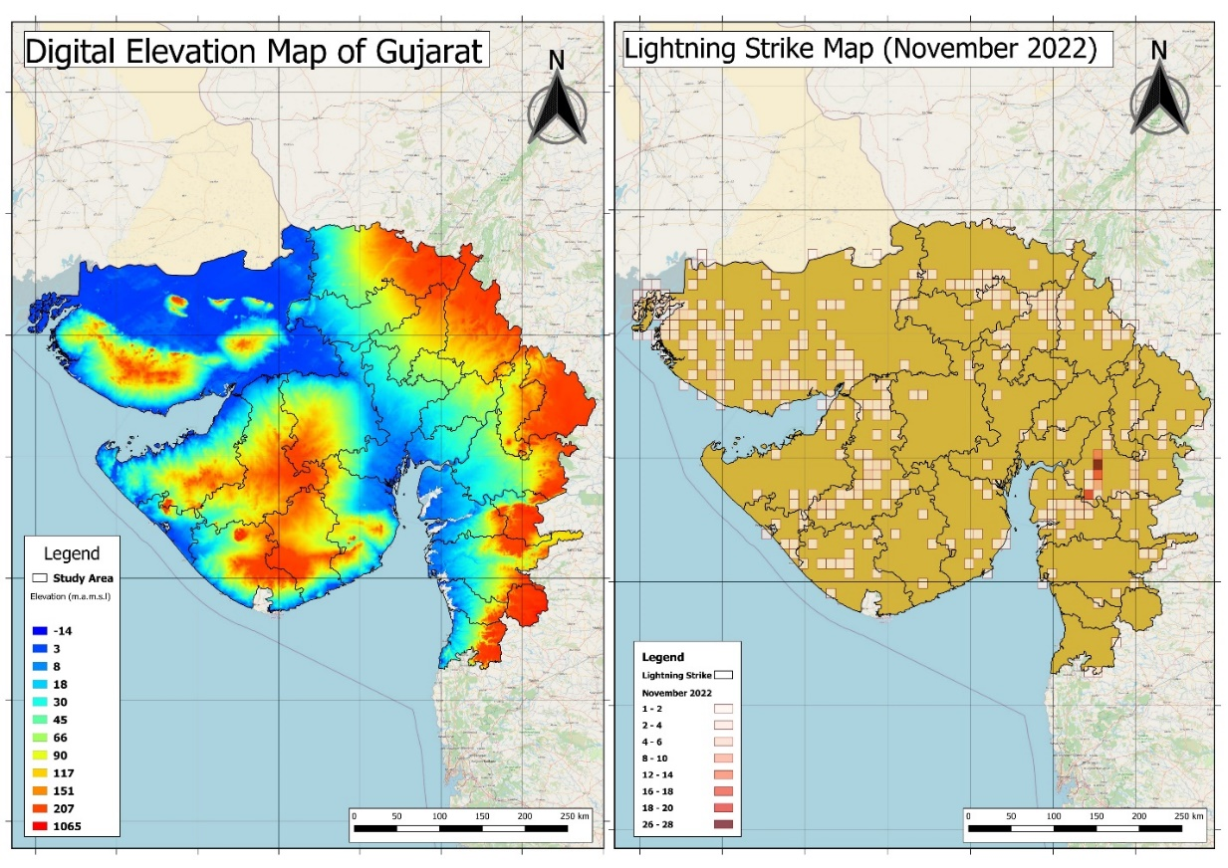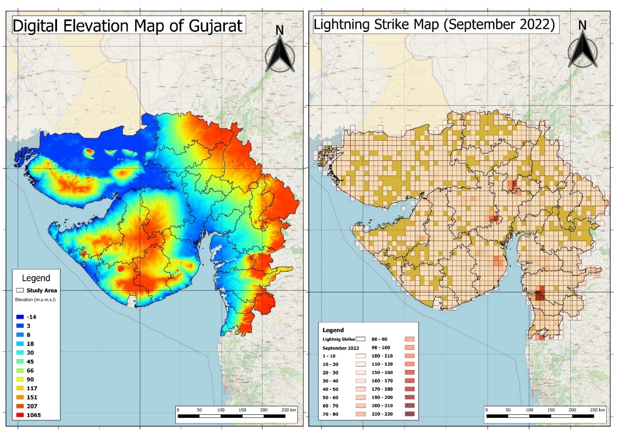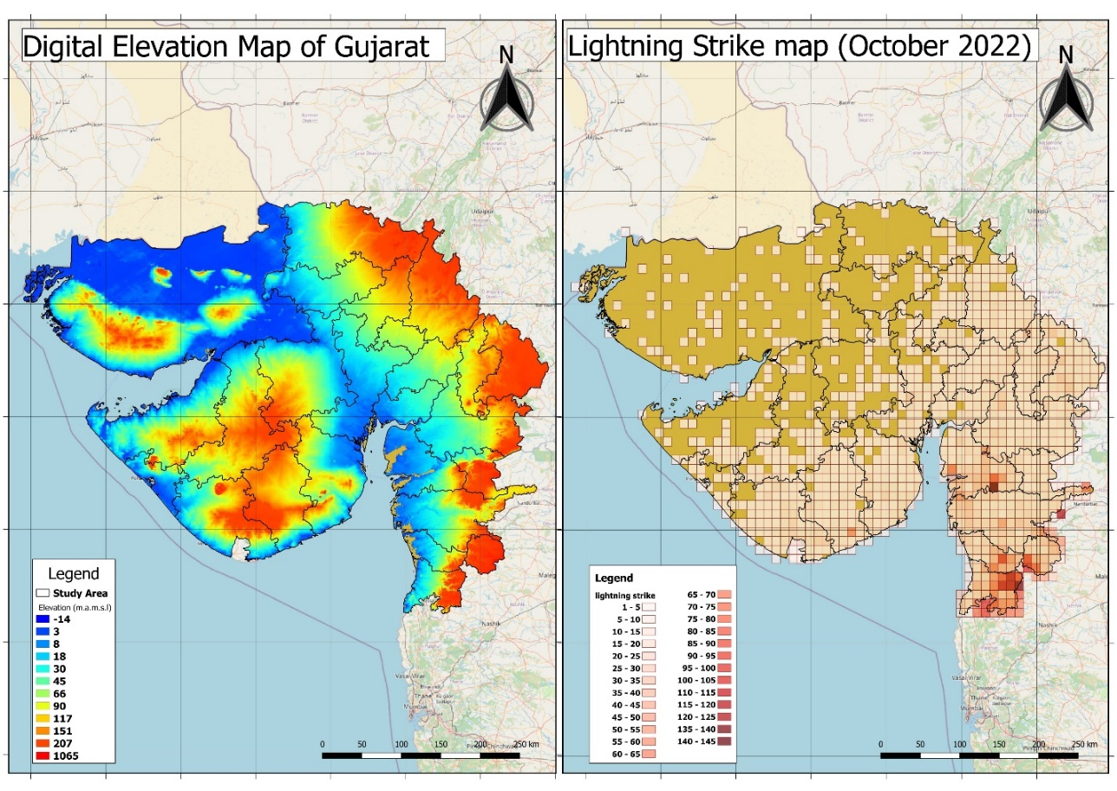

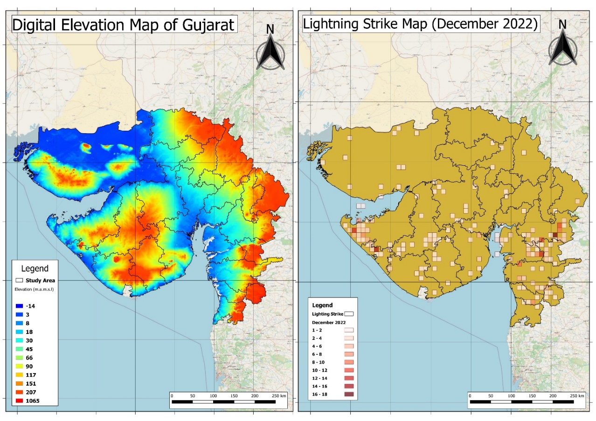

**Figure 2: Month wise aggregated lightning strikes from January to December 2023**

One day for each month with highest frequency of lightning strikes was selected and compared side by side to the wind speed and direction of that day and the temperature. From Figure 3, it was observed that, in regions with so many strikes the wind speed was low around 1-4 m/s probably causing the accumulation of clouds. It was noted that wind speed decreases when it hits the land area and more strikes have been observed where wind speed is neither very high nor very low (1-4 m/s). One pattern observed is that when the deceleration of wind speed happens while facing land resistance or when they are curving up due to elevation of land, then the clouds accumulate over regions making them vulnerable to more strikes. The speed of winds observed when winds curl, is mostly low (0-2 m/s).

Temperature is one of the responsible factors in the creation of clouds. Due to warm temperature, hot air rises up which causes water droplets to form and then it’s temperature drops resulting in condensation of water vapor and formation of clouds. As per Figure 4, almost all of the observed instances with lightning strikes have a temperature between 21-30 ˚C. For lightning to occur, the golden rule says that temperature is to be 12 ˚C or above.

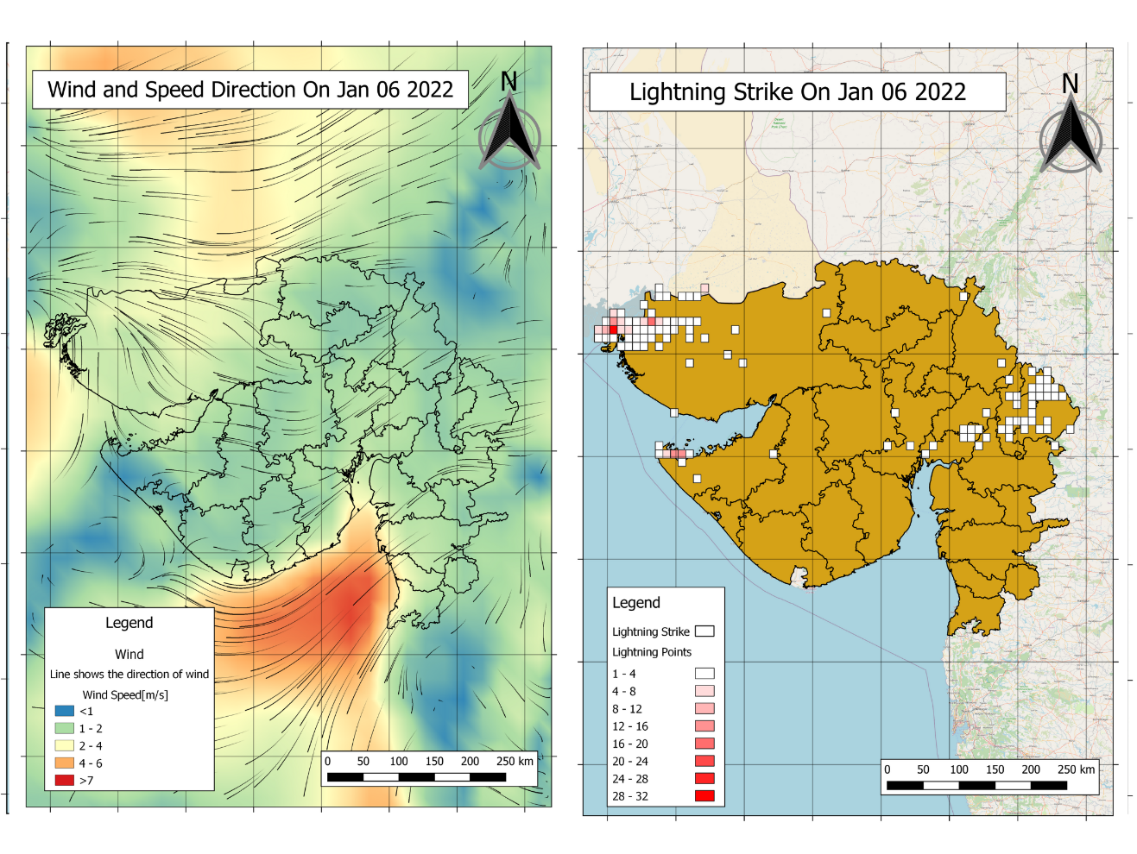

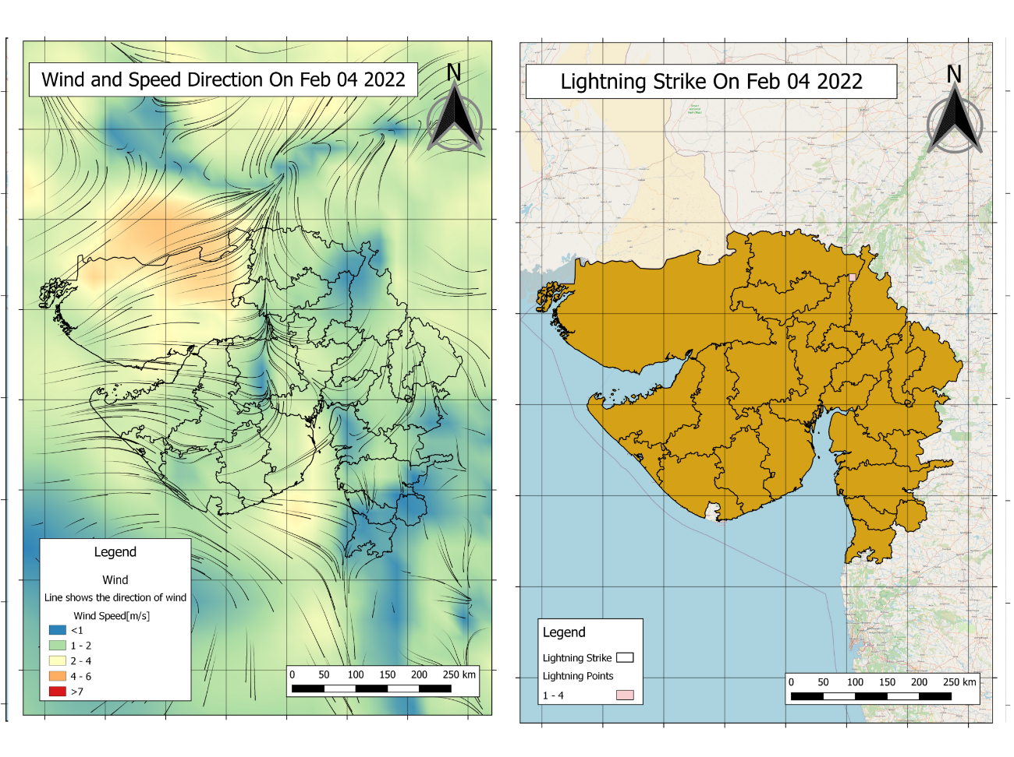

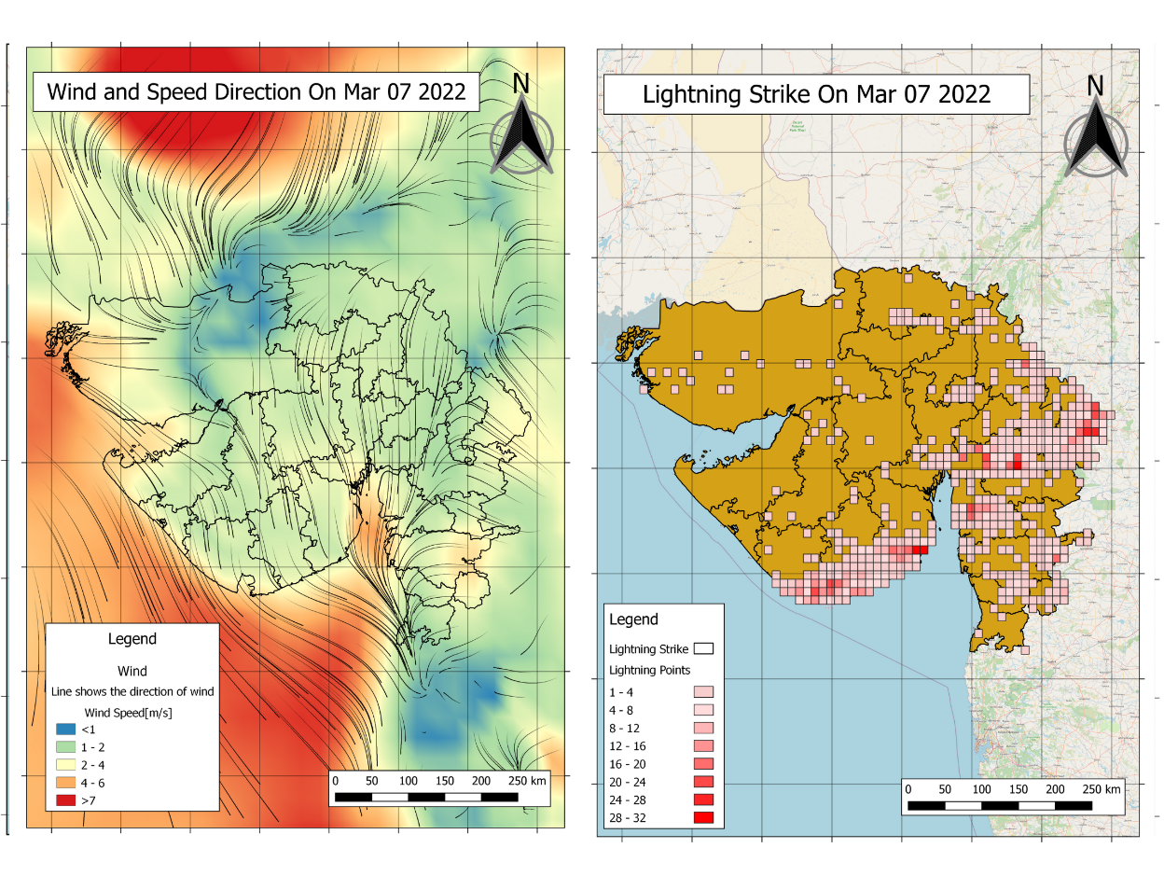

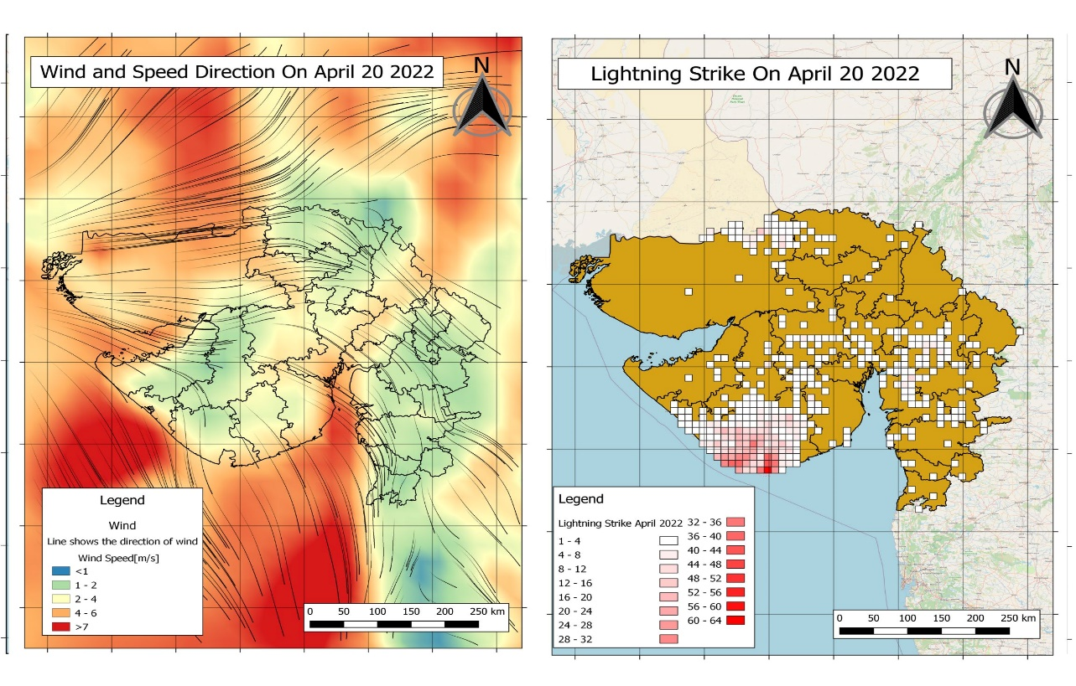

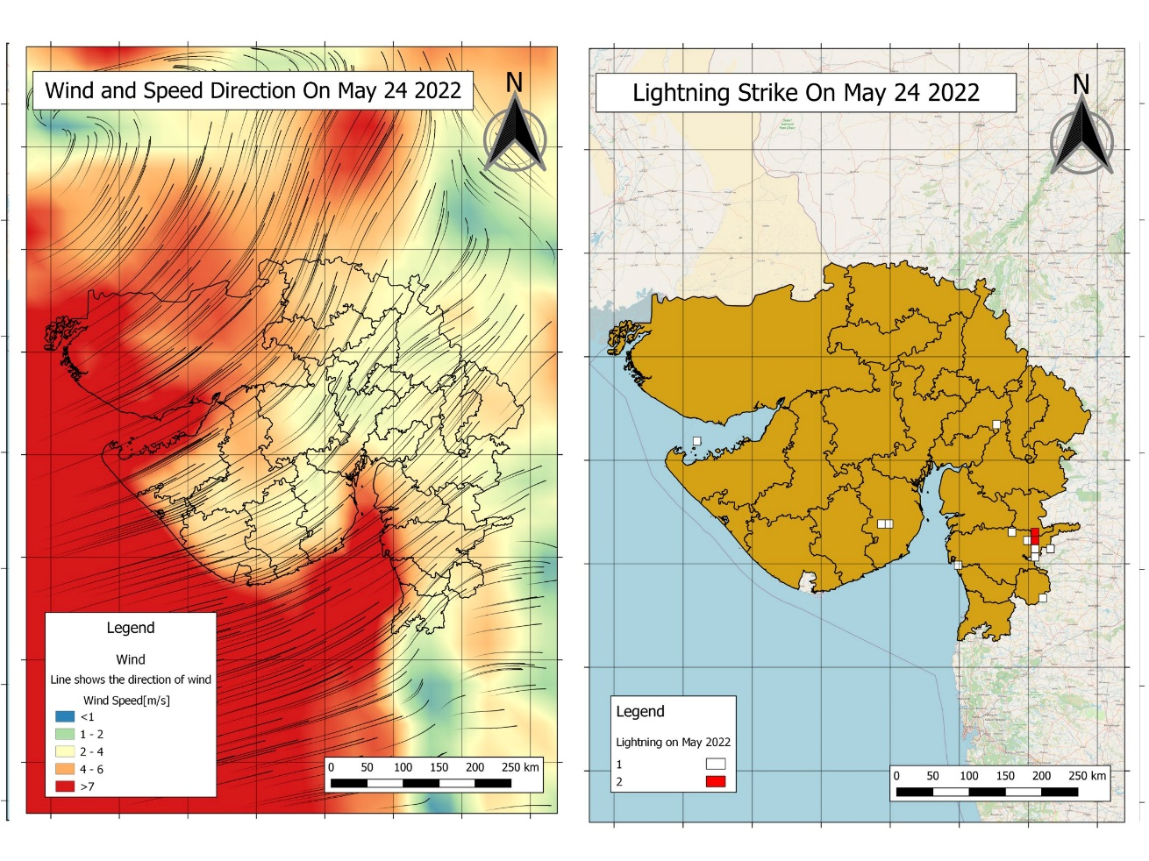

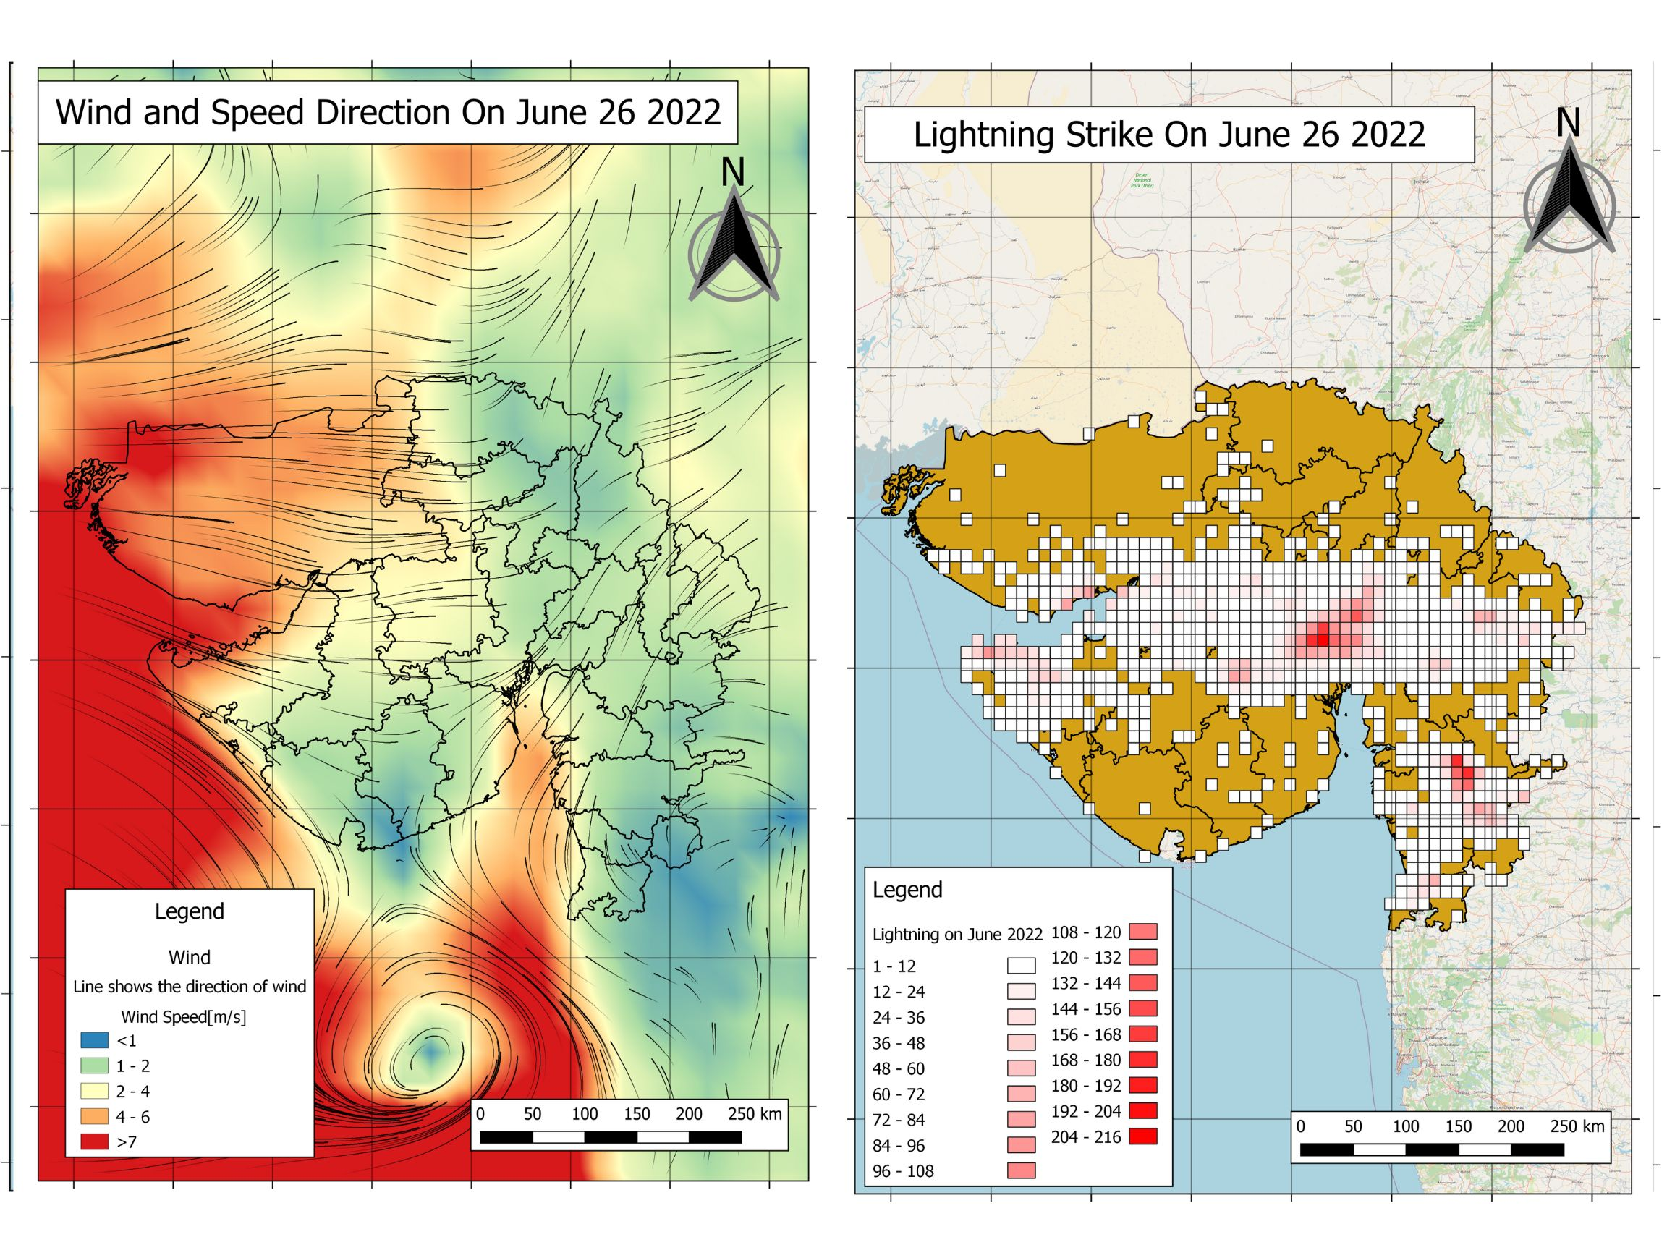

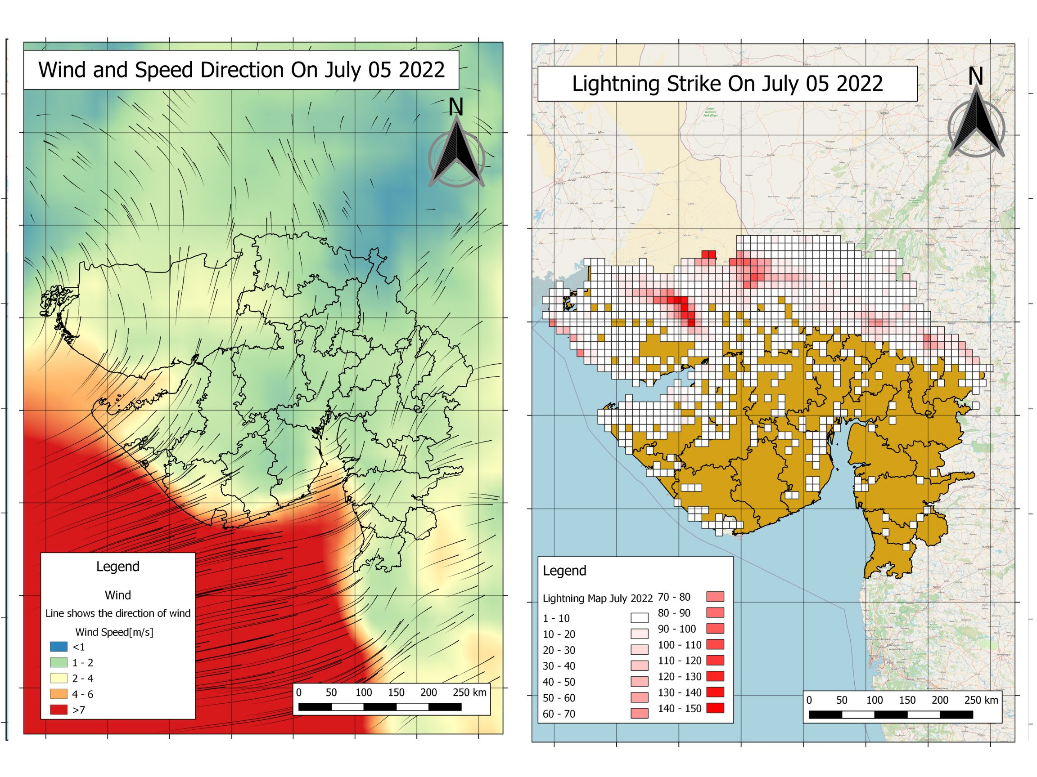

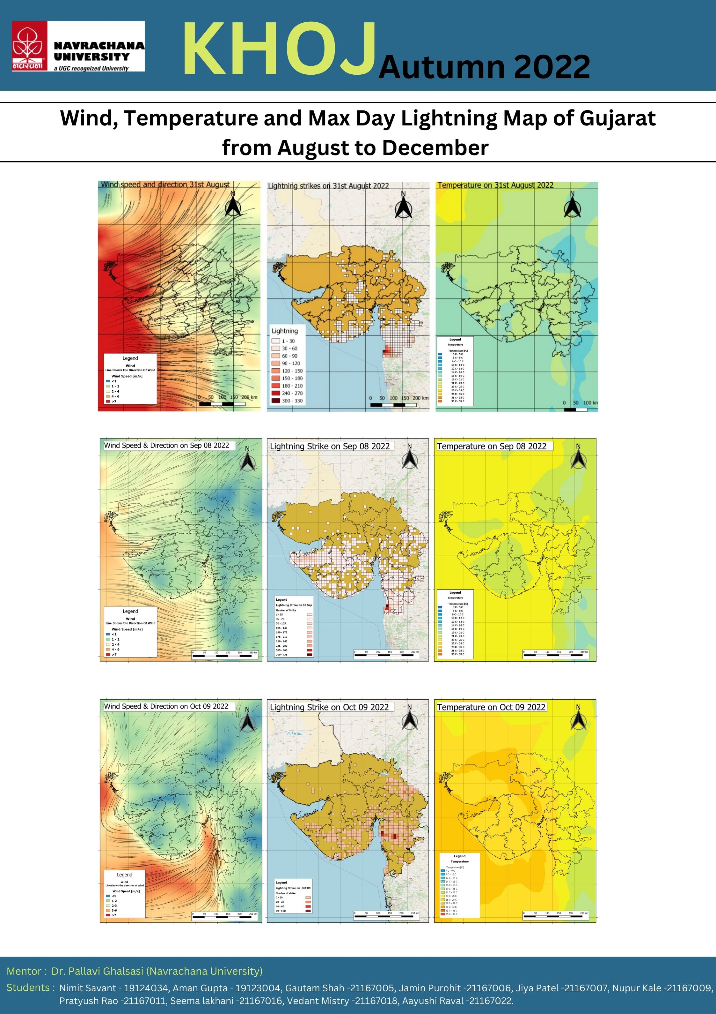





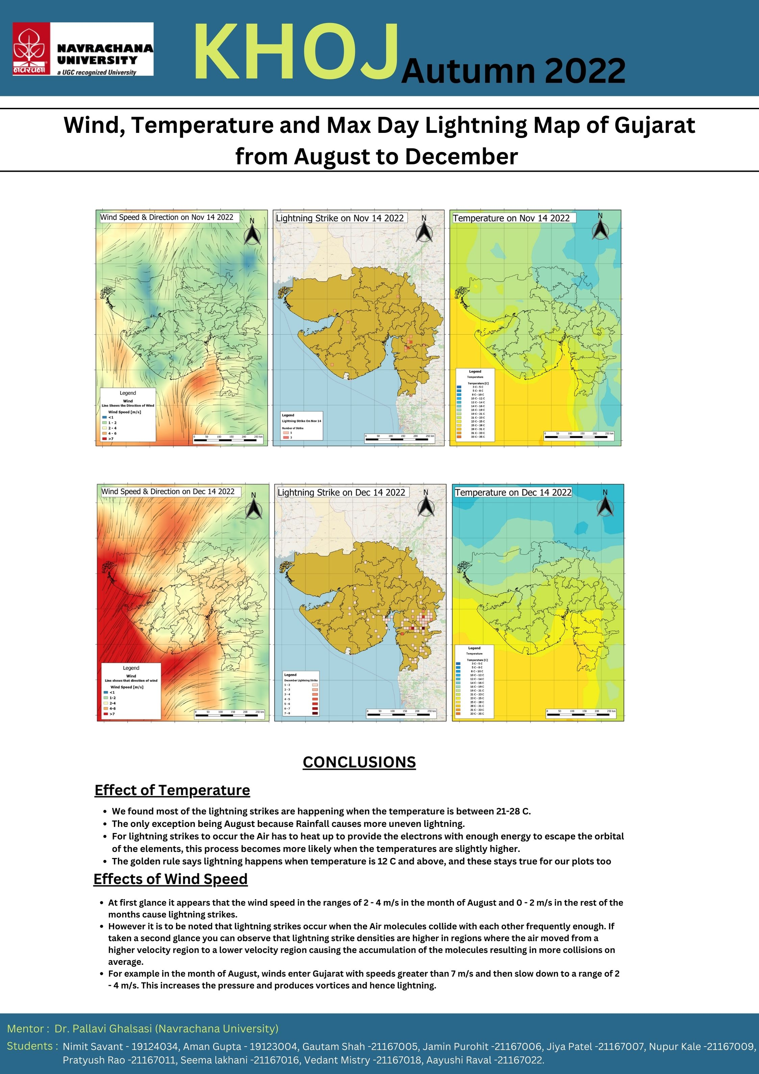

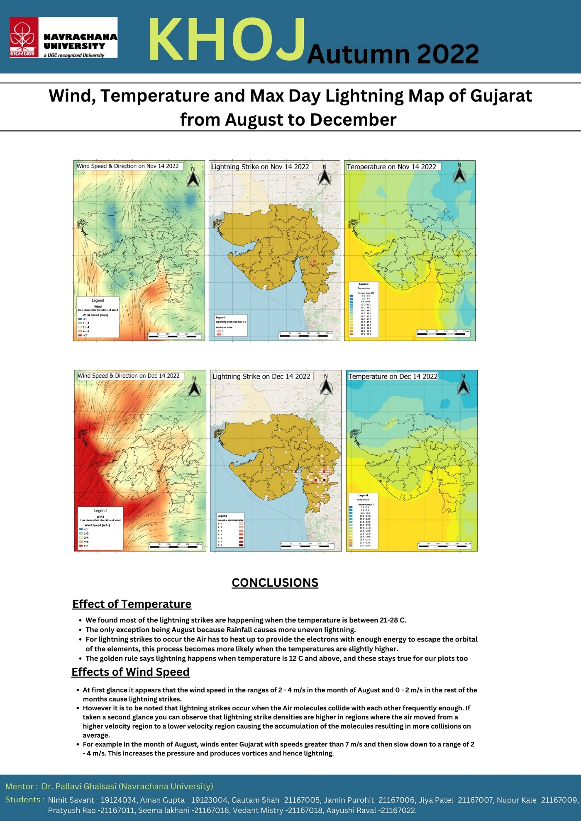

**Figure 3: Average Wind maps on the day of maximum lightning strikes each month**

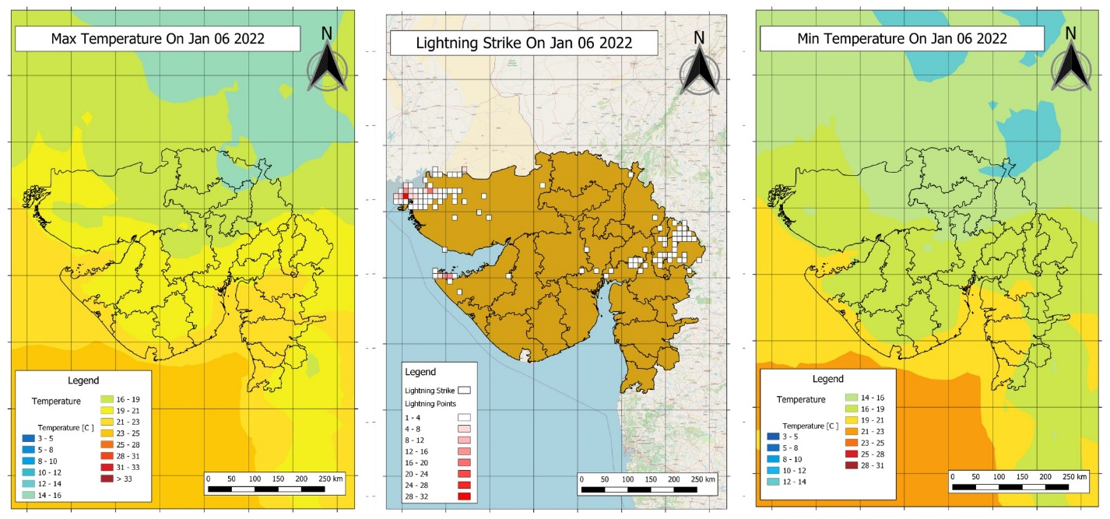

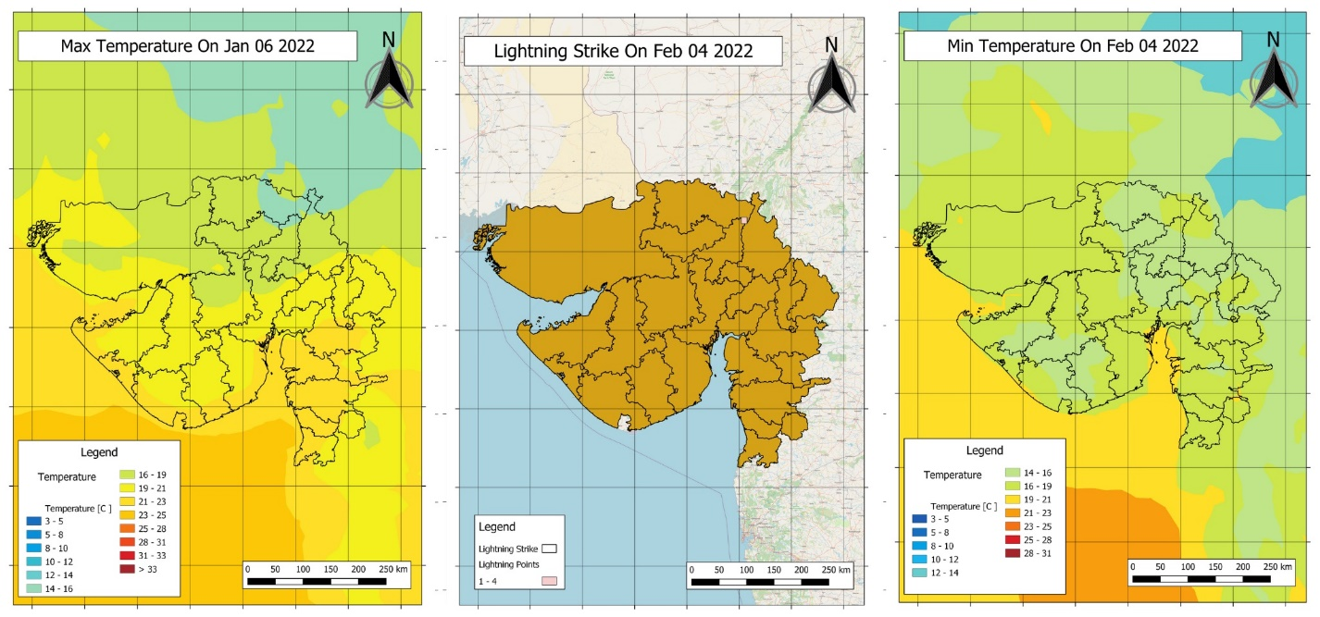

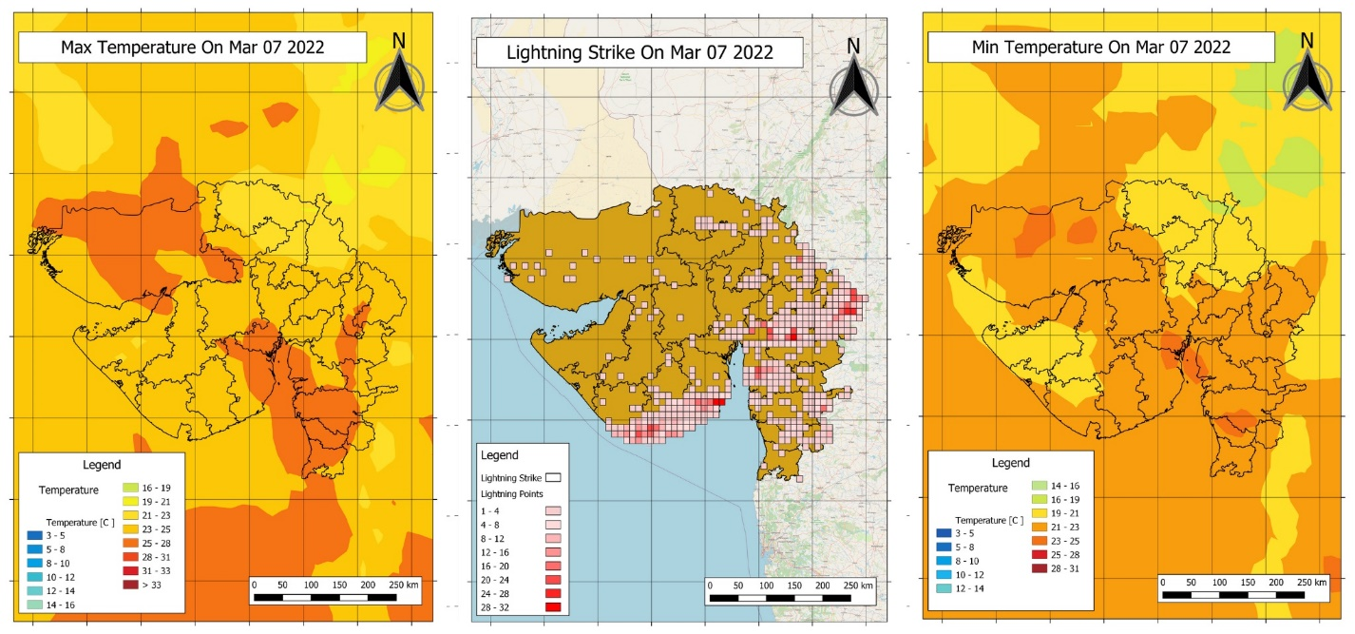

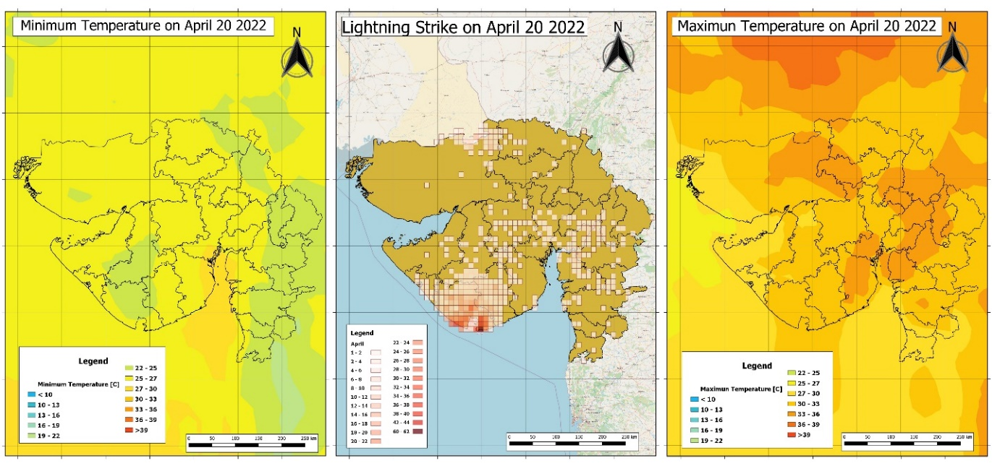

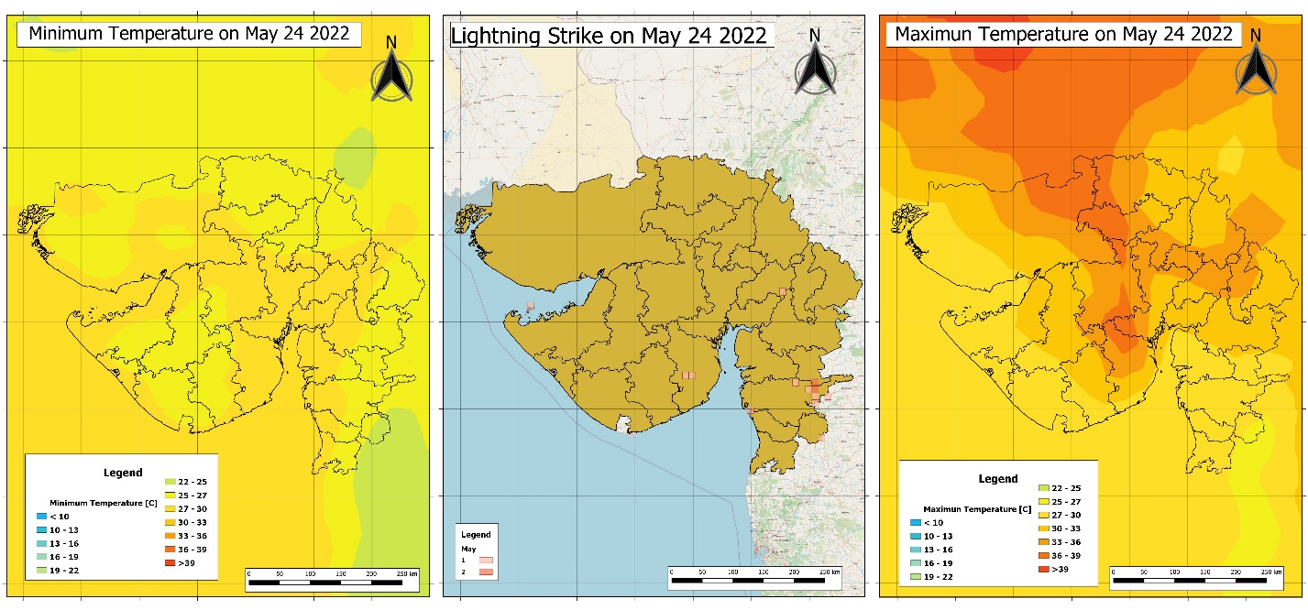

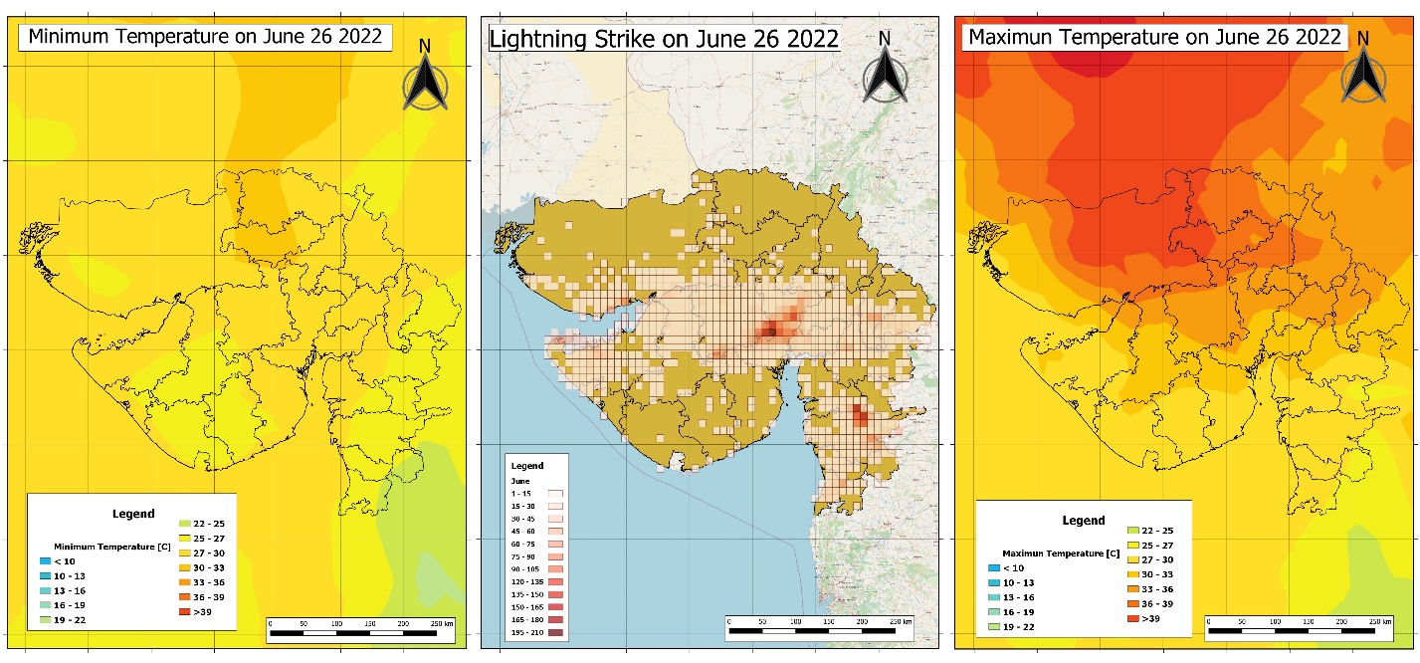

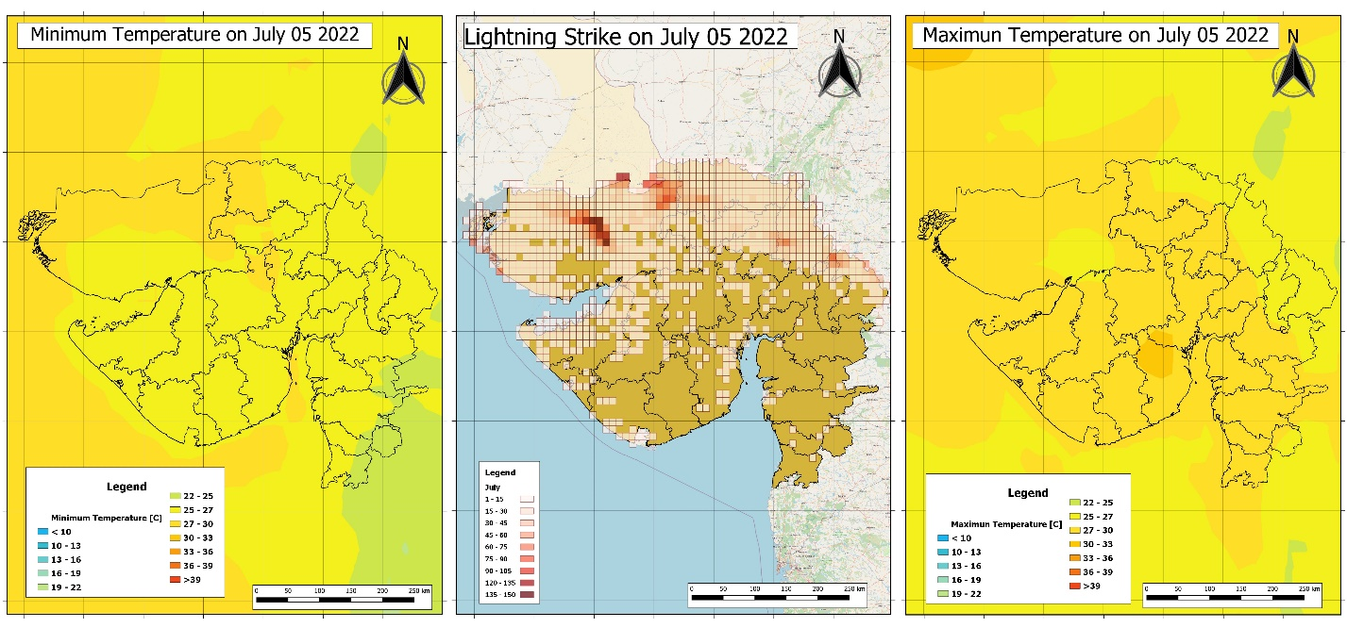

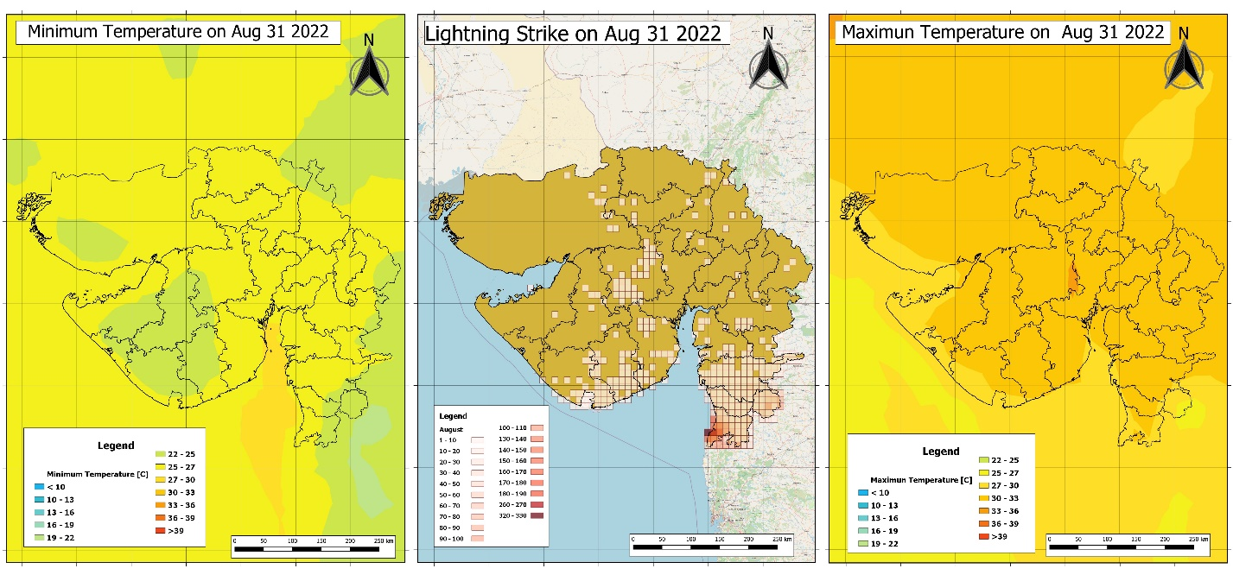

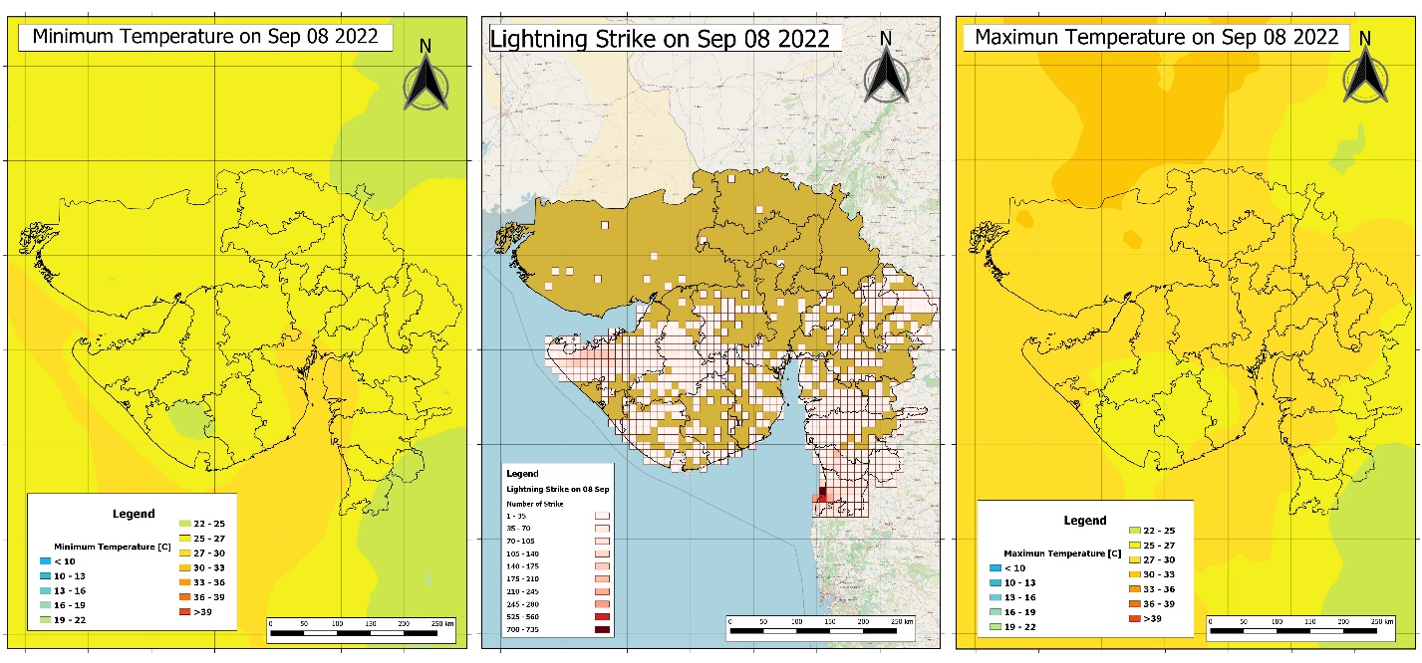

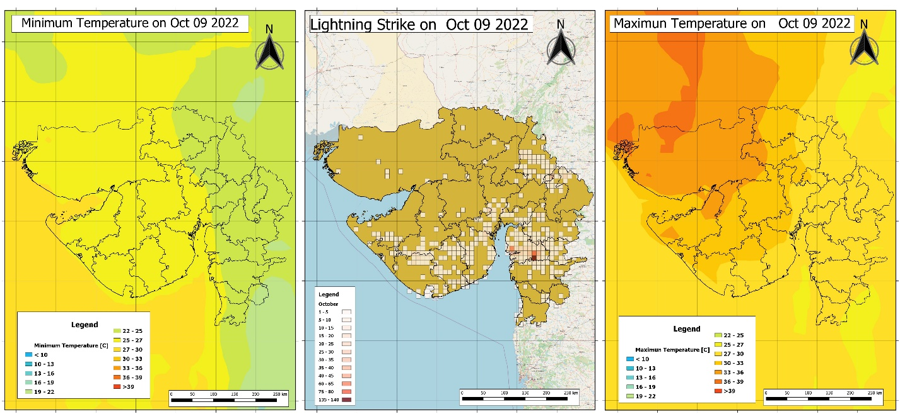

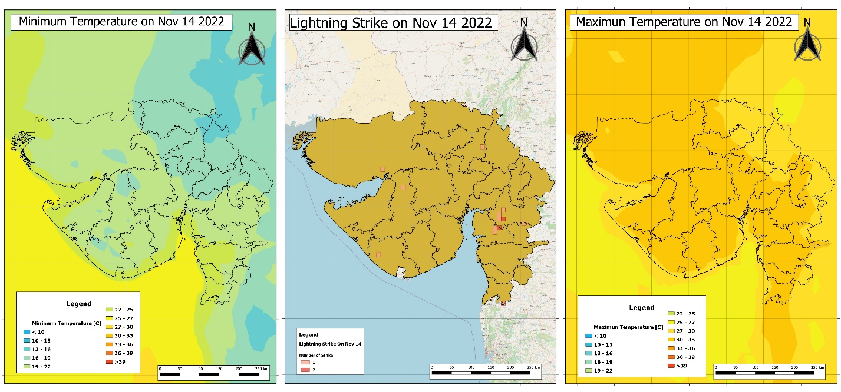

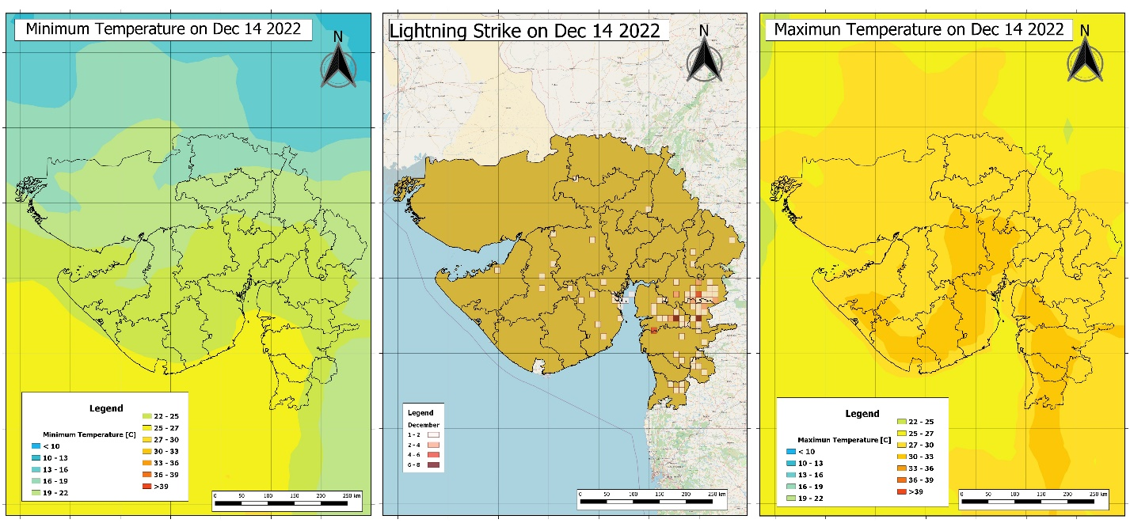

**Figure 4: Maps of maximum and minimum temperature on the day of maximum lightning strikes each month**

***Mapping of lightning incidents with data related to failure of electric transformers***

To assess the damage caused by lightning, the transformer failure data from 5 districts- Vadodara, Anand, Kheda, Panchmahals and Dahod was plotted (Figure 5) against the monthly sum of lightning strikes from the month of August to November 2023. It was then observed that many lightning strikes have occurred in regions with most transformer failures except November month where not many lightning incidents took place. However, this observation needs to be supported with further database so that a conclusion can be made on the transformers failures caused due to the lightning occurrences.

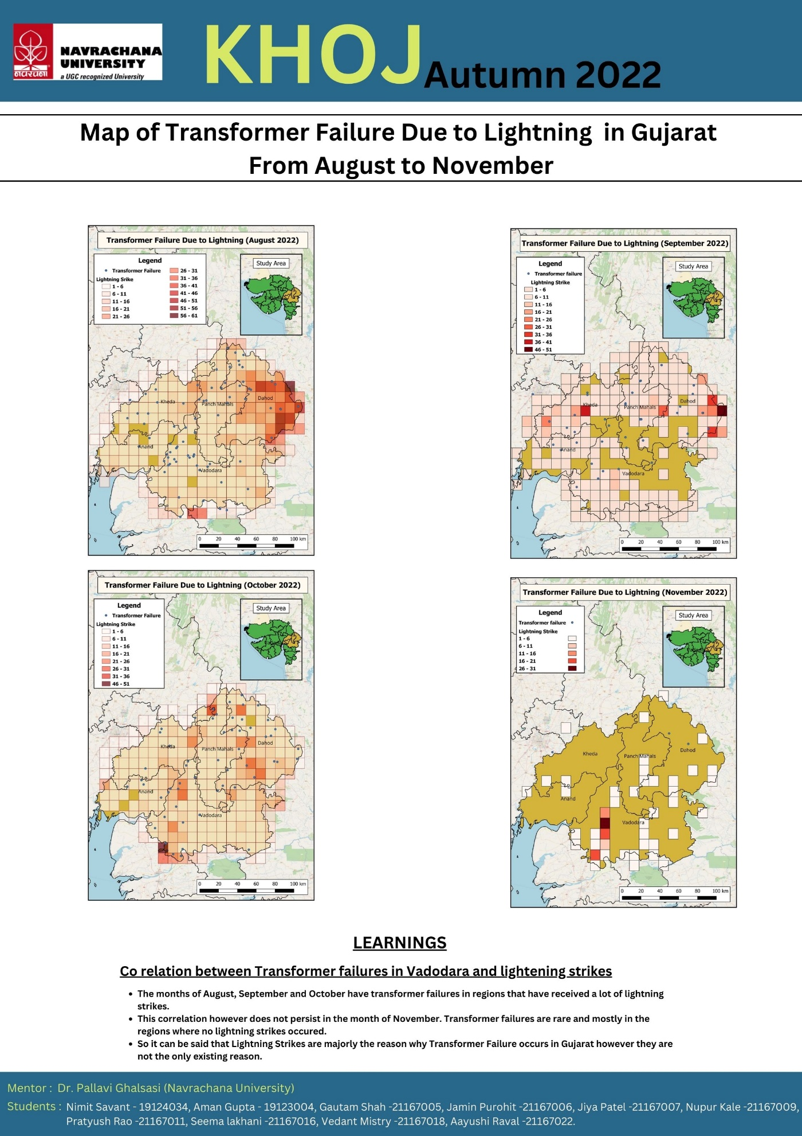

**Figure 5: Locations of failures of electric transformers in 5 districts around Vadodara during August-November 2022**

***Mapping lightning incidents with simulated weather data and finding correlation***

A KDE plot (Kernel Density Estimation) as shown in figure 6, maps the frequency of these numerical variables against the numbers repeated in the provided column for a particular parameter and draws a continuous and smooth estimation of the numbers repeated inside that column. The figure consists of the kernel distribution plots of different numerical parameters available in the dataset like temperature_2m_max (maximum temperature 2m above sea level during the day), temperature_2m_min, apparent temperature max and min, Frequency of shortwave radiation penetrating the atmosphere, amount of rain, precipitation and snowfall, dominant wind direction and speed, and evapotranspiration (the process of water on the surface of land being evaporated or being exhaled by plants). As The orange curve represents the distribution where the lightning strike did happen and the blue curve represents the distribution where the lightning strikes did not happen.

The reason why KDE plots have been chosen is arbitrary, it is up to the proficiency of the analyst as to what plot they choose to express their visualizations as. One could have chosen any other plot if it could express the idea better, however to the best of my knowledge, KDE plot would most appropriately express the distribution as it provides with the probability of an event occurring given it’s from a certain segment of your data.

One can see from figure 6, that the lightning strikes were more likely to happen at instances where the temperature 2 meters above sea level was in the range 25-28 °C whereas in the same range frequency of no lightning strikes is very low. Lightning strikes are also more likely to happen when the shortwave radiation sum is between 33-36. A lightning strike occurs every time the precipitation in millimeters are in the range of 0-15 mm. Any rainfall quantity outside of this provided range does not conclusively show any correlation with the probability of the lightning strikes occurring.

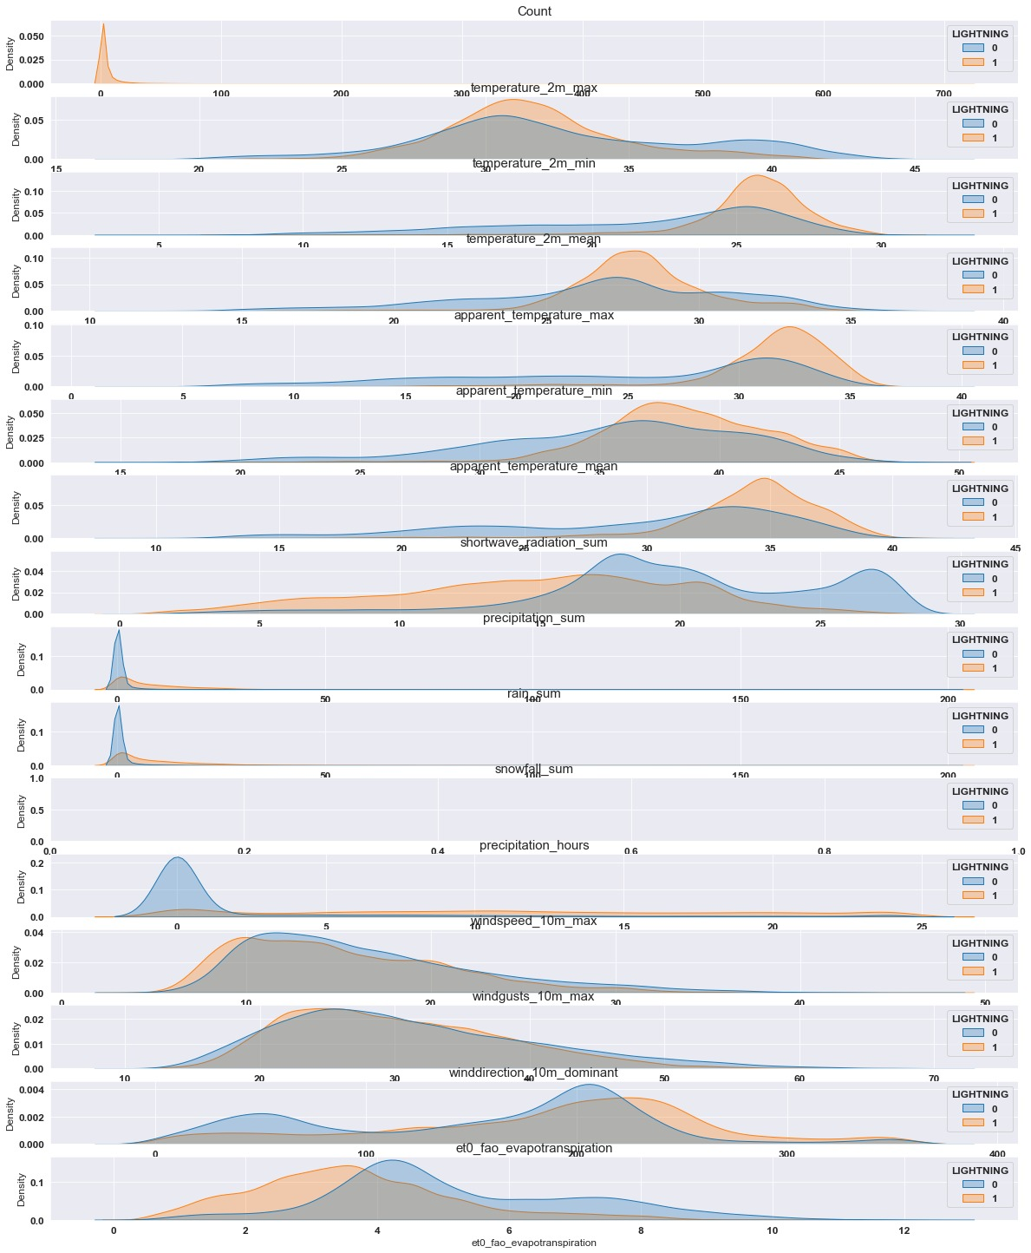

**Figure 6: Data distribution for different parameters**

When the eta-0 evaporation quantities are in the range 0 – 4 lightning strikes again are more likely to happen. Wind speed above 2.5-10 m/s was seen to be related to more lightning strikes. No significant dependence of the wind direction was observed on the lightning strikes as the distributions for classes 0 and 1 overlap with each other.

***Heuristic Approach to detecting whether or not the lightning will strike***

STEP – 1: Identify the anomalies

Anomalies, in this context, is referring to numerical ranges in our histogram that have a significant difference in the area under the curve. For example: Temperature 2m Min range from 38-45, Temperature 2m mean range from 0-18, Precipitation sum range from 0-13.

STEP – 2: Design a decision Tree

Once you’ve identified the anomalies you can design certain laws that will help you form a decision tree, for example: consider a data record where the temperature 2m min is in range of 38-45, temperature 2m mean is in range of 0-18 and precipitation sum in range of 20-30. In all these following ranges anomalies exist, numerically the probabilities of a lightning strike not happening is overall higher ( which can be inferred because the area under the curve is significantly higher for the 0 curve instead of the one curve ) so we can classify that record as 0 which means there won’t be a lightning strike.

The problem arises with this method because of lack of human precision, here we are roughly estimating a numerical decision tree based on the visual representations for the distribution of the parameters, which might give inaccurate results, which is when machine learning comes into play.

Machine learning automates the process of modelling a decision tree based on the approach we chose, however instead of using Visual representations a decision tree uses the concept of Entropy in your data which is based on the following formula:

E ( S ) = - SUM i=1 to N ( pi log pi )

Here, pi is the probability of having a particular class in certain subset and N is the total number of target classes.

Here the total number of classes is 2 ( Either the lightning will strike or won’t ).

Consider a random subset of 30 in your data, let’s say the number of 0 class is 12 and number of 1 is 18. The probability of getting a 0 is 12/30 or 0.4 and the probability of getting a 1 is 0.6.

The net entropy therefore is – ( 0.4 * log ( 0.4 ) + 0.6 * log ( 0.6 ) ) = 0.29

The model uses entropy to minimize the disorder into absolutely pure subsets ( as when a subset is pure the Entropy becomes ZERO )

The model used for this dataset is the XGBoost modebn l which uses multiple of such decision trees to get to an accurate conclusion, the explanation of how it works is given in the next section.

***Prediction Model on lightning incidents and comparison of results with real lightning data***

We further discuss the results of our prediction model and compare the results against the observations. The model was based on several parameters like temperature, rainfall, shortwave radiation, wind speed, wind direction, snowfall, precipitation and evapotranspiration. The classification report was generated using a machine learning classification model known as XGBoost, which is a tree based algorithm that uses the attributes provided in the dataset to classify an instance into either a record with lightning strike or a record without lightning strike without excessive scaling.

The XGBoost algorithm can be disintegrated into the following 10 steps, it works as follows:

a. **Initialization**: In this step, we start with an initial model that predicts the target variable (whether lightning will strike or not) based on the given weather parameters. The model makes an initial prediction using the provided features.

b**. Residual Calculation**: Calculate the difference (residual) between the predicted target values and the actual target values. This step helps us understand the errors made by the initial model.

For example, let's say the initial model predicts that lightning will strike (target value = 1), but the actual target value is 0. The residual for this instance would be -1 (0 - 1 = -1).

c. **Building Decision Trees**: In XGBoost, we build decision trees to capture and correct the residuals. We train these decision trees to predict the residuals instead of the actual target values.

Using the provided weather parameters as features, the decision tree learns patterns and relationships in the data that can help improve the predictions. Each tree focuses on correcting the errors made by the previous models.

d. **Gradient Descent Optimization**: XGBoost utilizes gradient descent optimization to adjust the model's parameters and minimize the residuals. This step involves calculating the gradients of the loss function with respect to the predictions and updating the model accordingly.

The gradients represent the direction and magnitude of the steepest descent. By taking steps in the direction opposite to the gradients, we iteratively update the model's parameters to minimize the residuals and improve the model's performance.

e. **Combining Models**: The predictions of the new decision tree models are combined with the previous models to update the ensemble model. The ensemble model aggregates the predictions from all the weak models.

For example, if we have multiple decision trees and each tree predicts a residual of -1 for a specific instance, the ensemble model would sum up these predictions to get a more refined residual estimate.

f**. Regularization**: XGBoost applies regularization techniques to prevent overfitting and improve the model's generalization. Regularization helps control the complexity of the individual decision trees and the overall ensemble model.

Regularization techniques in XGBoost include controlling the depth and complexity of the trees, adjusting the learning rate (step size), and adding penalties to the loss function. These techniques encourage simpler models that generalize well to unseen data.

g. **Iterative Model Building**: The steps from c to f are repeated iteratively, building new decision trees to capture and correct the residuals, optimizing their parameters using gradient descent, combining them with previous models, and applying regularization. This process continues until a stopping criterion is met or a specified number of iterations is reached.

h. **Final Model**: After building multiple weak models and combining them, the final strong predictive model is obtained. The final model incorporates the collective knowledge and insights from all the decision trees to make accurate predictions on new data.

i. **Prediction**: To make predictions on new data, we pass the weather parameters through all the weak models. Each weak model makes a prediction, and their predictions are combined to produce the final prediction of whether lightning will strike or not.

For example, if the first weak model predicts a residual of -1, the second weak model predicts a residual of 0, and the third weak model predicts a residual of 1, the final prediction would be obtained by summing these residuals (-1 + 0 + 1 = 0). If the resulting sum is positive, the final prediction would indicate that lightning will strike, otherwise, it would indicate that lightning will not strike.

Through these steps, XGBoost effectively leverages the provided weather parameters to iteratively build and optimize an ensemble of decision trees, capturing complex patterns and improving the model's

Precision computes the number of instances correctly classified over the total number of instances, similarly recall computes the number of correctly classified instances over the total number of instances predicted as the current label.

The F1-score = 2*precision*recall/ (precision + recall)

After the model was trained, following metrics was obtained (Figure 7).

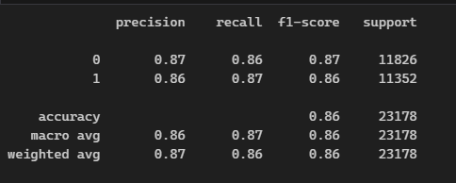

**Figure 7: Classification Report**

As described before here 0 stands for no lightning strike and 1 stands for a lightning strike. The model is under sampled which means that extra 0 records were eliminated, so the overfitting is not a problem. In this case, the precision of the model predicting 0 is 0.87 which in means that 87% of the times the model will predict 0 correctly given that the dataset follows the considered trend. The precision of 1 is also 86 % indicating that 86 percent of the times the model can predict a strike correctly for the given dataset. The recall score tells you what proportion of the actual values is it predicting correctly. So in this case the recall score of 0 is 86% indicating that out all the 0’s 86 percent of them have been classified correctly same goes for the 1’s.

The dataset itself includes data points from throughout the year with around 630k records, out of which only 33k are records with a cloud to ground lightning strikes. So almost 500 k zero records were deleted for this model to be developed without overfitting on the dataset. Anomaly detection algorithms were deployed but they unfortunately didn’t work as well as we assumed they would, which is an indication that the variation factor that is majorly contributing towards cloud to ground lightning strikes is missing from this dataset.

However, to visualize the separation between data records that had a cloud to ground lightning strike versus data records that don’t have strikes, we used principal component analysis (PCA) to plot them on a 3-D graph and see them on our console. Here is a still from the interactive rendered template (Figure 8).

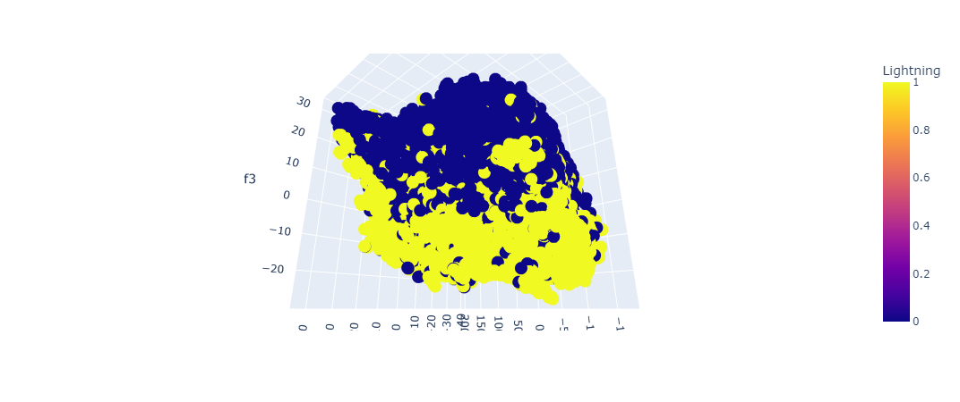

**Figure 8: PCA based 3 dimensional visualization of data records with (yellow) and without (blue) lightning strikes**

The yellow points are records where the lightning strikes did happen and the blue ones are records where they didn’t. One can see an approximate plane of separation between the two classes which is what the model is trying to capture as well.

Figure 9 is a confusion matrix obtained after the model was trained on the training set and then tested on the testing set. A confusion matrix is an efficient way to interpret the accuracy of your classification model and where or how it needs to be modified.

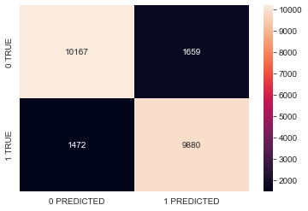

**Figure 9: Confusion Matrix**

On the y-axis plotted are the actual bins of the lightning strikes and on the x – axis the values predicted by the model. The matrix implies correctly predicted instances across the diagonal.

The model successfully predicted 87 % of the records correctly. There is a 17.1 % chance however that the predictions will detect severe lightning but it will be a false alarm, and a 12.98 % chance that it will be predicted to be low but there will be severe lightning strikes. The probability in the latter half is known as a Type 2 error and such a scenario must be absolutely avoided. 5.46 % in case of life and death is still a severe probability and this number must be reduced.

The model poses following limitations.

1. The dataset engineered for the model is accumulated and linked through multiple sources. Since the data was unavailable, measures were made to collect data through API’s and join them together.
2. Furthermore, the API from which the dataset was generated produces Simulated weather data and not actual measurement. The predictions are entirely relied upon the fact that this simulated data is accurate.
3. The time duration of the data used to make the model is from January to December 2022. A model based on such a short time span cannot be relied upon for long term predictions.
4. When the model was used to perform without deleting records it was not able to distinguish the records as perfectly as it did with the training validation and testing sets. This indicates that the lightning strikes problem could be a time series problem an approach that we are looking into as of now.

**Summary**

This project enabled the authors to comment on how climatic and demographic factors affect the frequency and distribution of lightning strikes and the vulnerable locations for lightning across the state of Gujarat. Our work suggests installation of metallic objects or high pointed objects over tall buildings and areas with very high urbanization degree in order to minimize damage due to lightning over built area.

**Acknowledgements**

Authors acknowledge National Remote Sensing Center (NRSC), Indian Space Research Organization (ISRO), Hyderabad for providing entire lightning data. We acknowledge Gujarat Electricity Board (GEB), Vadodara for providing data on failures of electric transformers. We thank open repositories ------------ for providing the data used for the present work. We acknowledge ---------, -------, -------, ------ for plotting the lightning data and discussions. We acknowledge deeply Navrachana University for providing the much needed support and motivation to conduct this research study.

**References**